**Cooling Case for Raspberry Pi HQ Camera and Raspberry Pi**

I have been intrigued by the Raspberry Pi HQ camera since the time it was released. So much, that I bought three of them one after the another. I have been doing some astrophotography with the camera with quite decent results. I believe the limiting factor has been the lens that I have used and the barndoor tracker that I made and have used. I always wanted to try and cool the camera chip and see how it fares. It was cumbersome fixing a peltier with a heat sink and a cooling fan. The entire weight of these would be on the PCB and I feared it might get bent or damaged. I had fixed the camera and a RPi case on two sides of a small piece of plywood using spacers and screws. But again, the weight of the RPi and its case was all born by the PCB.

My focus for designing this case was on three things –

1. Keep the weight off the PCB.
2. Make it easy to fix a peltier for cooling the camera chip.
3. Make it adjustable enough to avoid using peltier, but keeping the form and usefulness of the case.
4. Make is easily mountable on various types of ball heads.

The parts used –

1. Rapberry Pi – 4
2. Argon neo case – I removed the cover to allow passage of the flat cable of the RPi HQ camera. The case is a big heat sink and works well to keep the temperature of the Pi reasonably low. With the fan installed, the temperature went even lower.
3. 6inch fan – Sunon 4143/MF60151VX-1000U-A99 (<https://www.digikey.in/en/products/detail/sunon-fans/4143-MF60151VX-1000U-A99/9838580>)
4. TEC1-12715 Peltier (<https://www.amazon.in/gp/product/B07S9VT2YT/ref=ppx_yo_dt_b_asin_title_o00_s00?ie=UTF8&psc=1>)
5. W1209 temperature controller thermostat (<https://www.amazon.in/gp/product/B00Q6WQJ2O/ref=ppx_yo_dt_b_asin_title_o07_s00?ie=UTF8&psc=1>)

**Please read the note at the end before starting assembling.**

1. Acrylic case for the W1209 (<https://www.amazon.in/gp/product/B08PRXRQHJ/ref=ppx_yo_dt_b_asin_title_o08_s00?ie=UTF8&psc=1)>

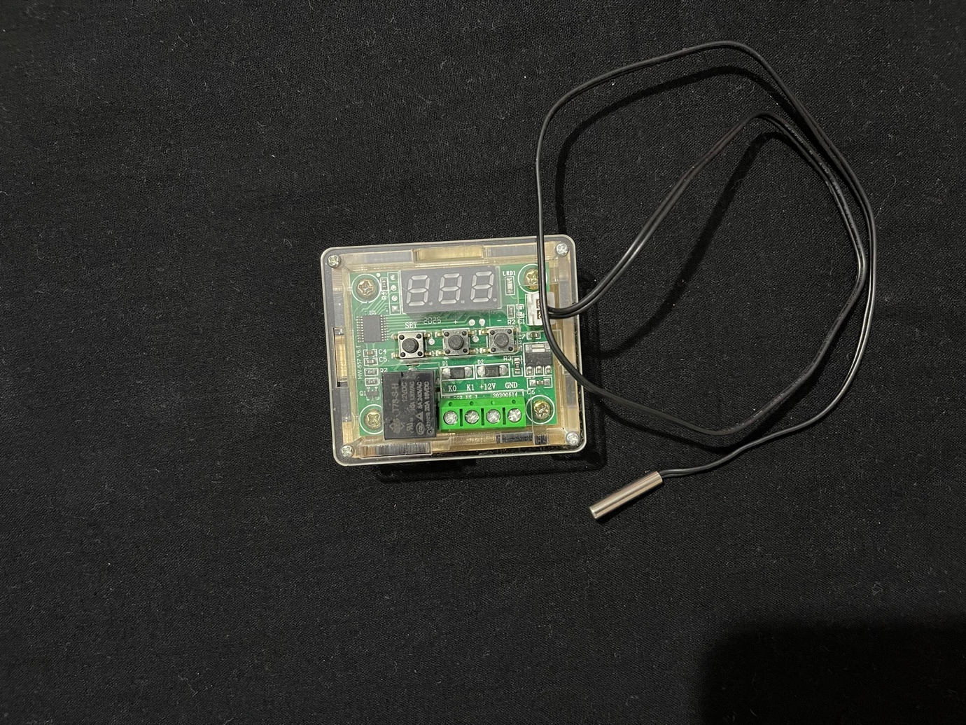

Photo-1

Temperature controller in the acrylic case.

1. 3 Pin Female DC Power Jack Panel Mount (<https://www.amazon.in/NextGeekTM-5-5mm-Female-Socket-Electrical/dp/B07NYD2FLJ/ref=sr_1_14?dchild=1&keywords=Female+Socket+Panel+Mount+Jack+DC+Connector&qid=1635086399&sr=8-14>)
2. A 40x40x2mm aluminium plate – cut from an old aluminium baking tray.
3. Another aluminium plate of size 44x45x2mm.
4. 40x40x25mm Tall Blue Heat Sink – meant for ODROID-XU4 (<https://www.fabtolab.com/xu4-heat-sink>). The plastic fixing tabs were removed.
5. Screws –

|  |  |  |  |  |
| --- | --- | --- | --- | --- |
| S.No. | *Screw Size* | *No* | *Nuts* | *Site* |
| 1 | M2.5 x 6mm | 6 | 6 | the PCB plate; heat sink with Part - 5 |
| 2 | M3 x 15mm | 8 | 8 | Part – 1 & 2 tightening and quick release plate (Part – 12). |
| 3 | M3 x 30mm | 16 | 16 | Parts 1,2,3,4,5,6 -2 screws; 4 screws for tightening the RPi Bracket (Parts – 10 and 11), fan (Part – 8) and Mesh Bracket (Part – 9), air duct with RPi Bracket ( Parts 6,7 and 10) |
| 4 | M3 x 45mm | 2 | 2 | top n bottom with air duct (Parts 1,2,3,4,5 with 6) – the other side |
| 5 | M4 x 25mm | 4 | 4 | Tightening the fan with Part - 8 |

1. The 3D Printed Parts –
   1. Part nos – 1 (left) and 2 (right) 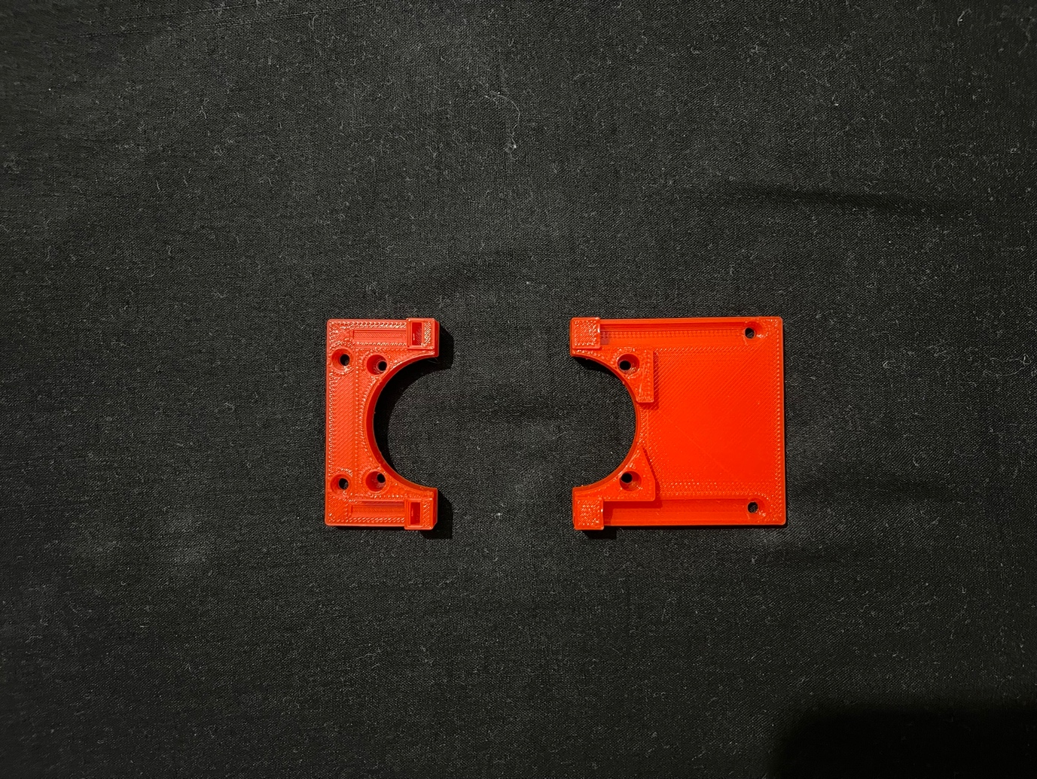

Photo-2

Hold the camera just below the backfocus ring. The PCB is screwed to the four holes.

* 1. Part No – 3 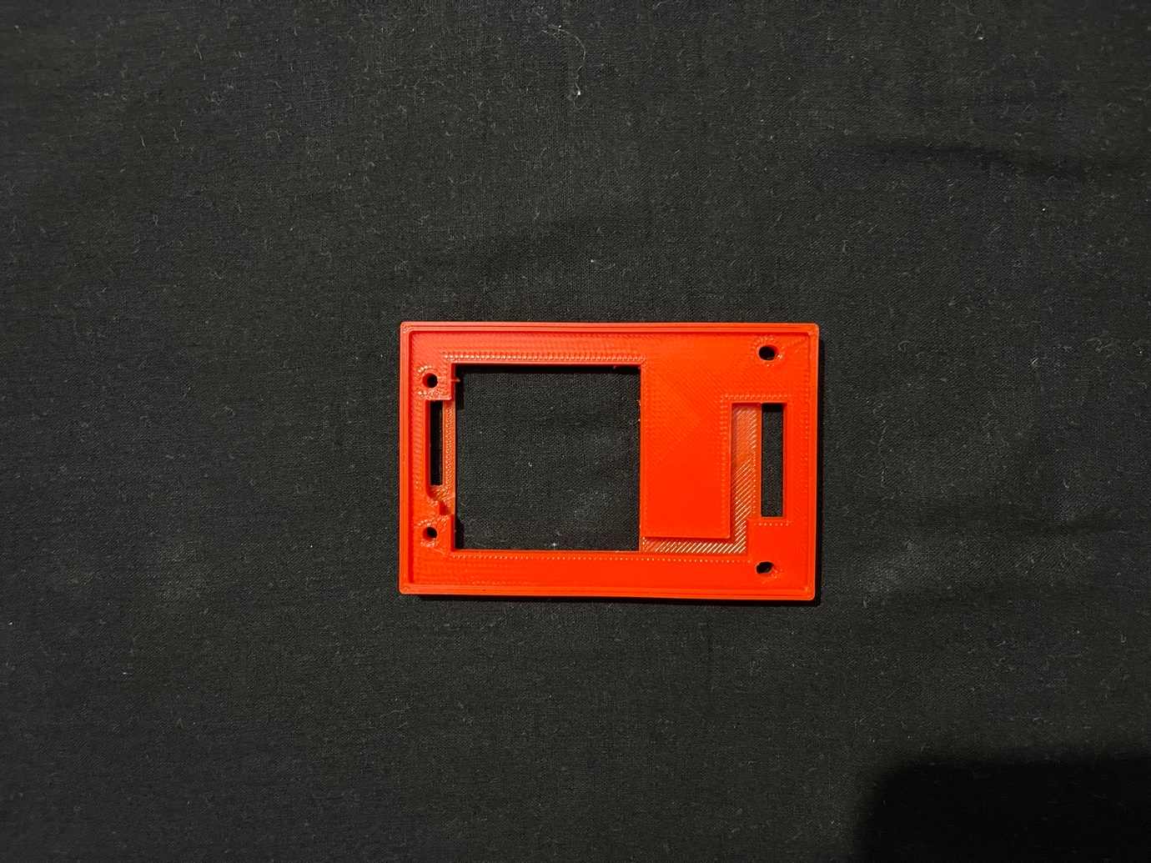

Photo-3

Sits below the above and has groove for the temperature probe and its wire.

* 1. Part No – 4 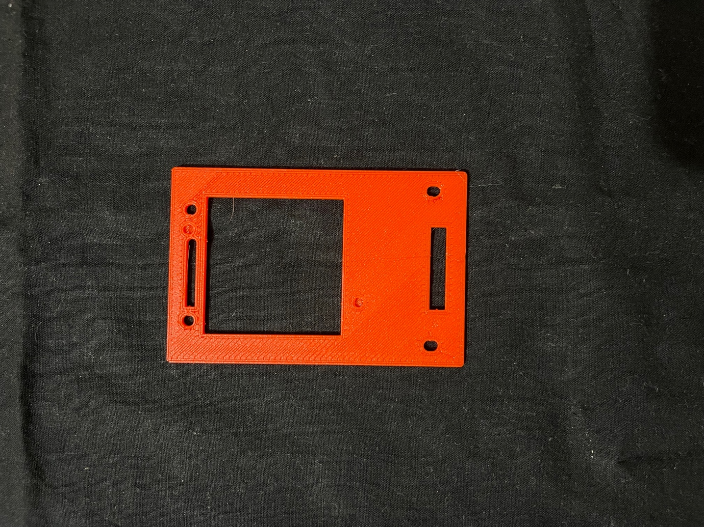

Photo-4

Goes below part 3. Can be printed with the part 3 as one piece.

* 1. Part – 5 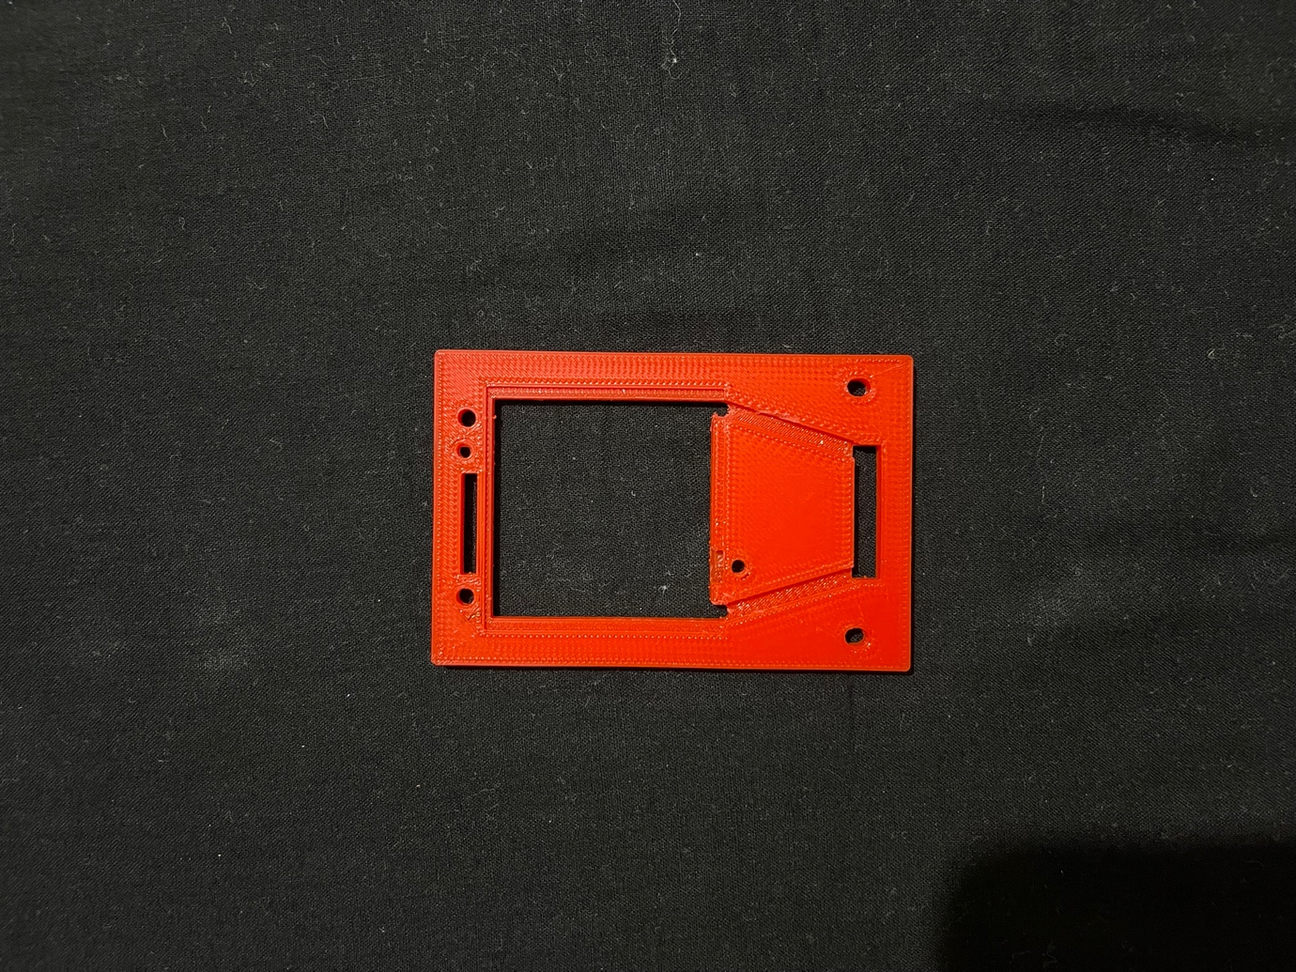

Photo-5

Goes below part 4. It has grooves for the peltier wires and space for the aluminium plate. Above the aluminium plate sits the peltier. There are foles for screws which will hold the heat sink in place. The side visible in the above picture is the bottom side of the plate.

This was a later addition, after I realized a problem with the design in which the peltier was kept directly below the camera PCB (separated by thermal tape only). More about it later.

* 1. Part – 6

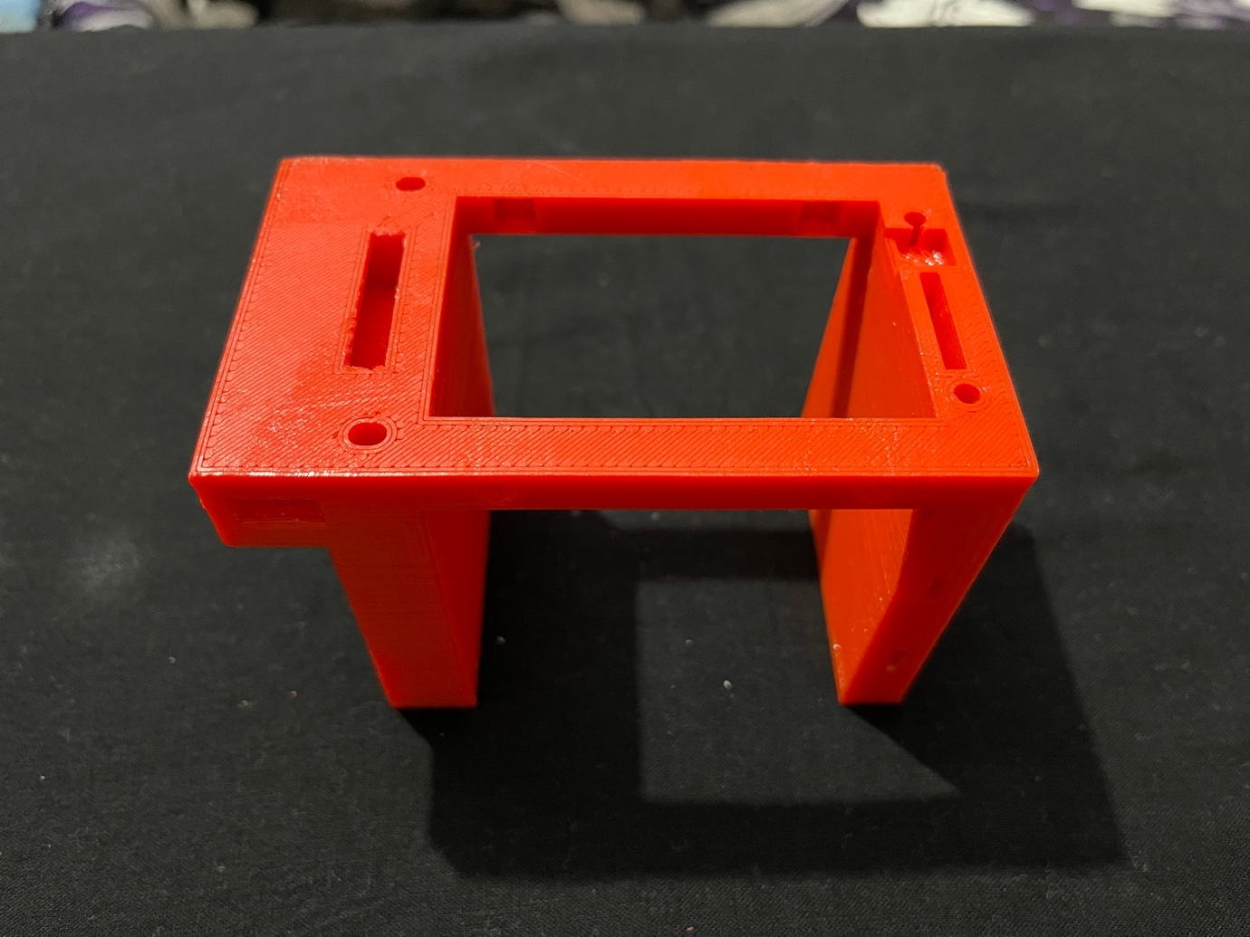

Photo-6

This is the, as I call it, the air duct. It has passage for the wires of peltier and temperature probe on one side (the projecting side) and the flat cable of the camera on the other side. There is another cut out for the screw head that holds the heat sink in place.

* 1. Part – 7 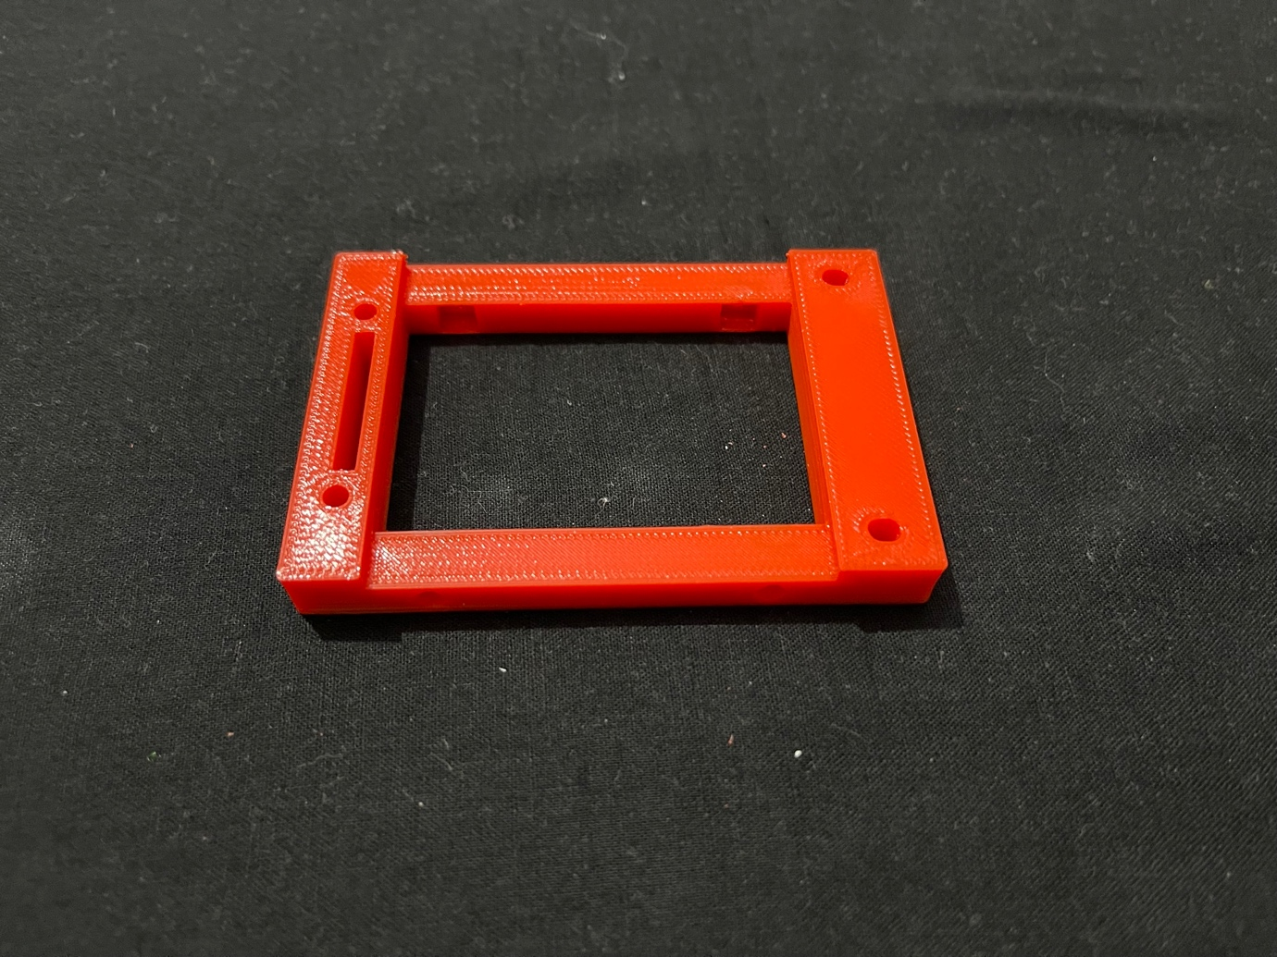

Photo-7

This fits below the ‘Air Duct’. It ahs slot for passing of the flat cable.

This forms the ‘Air Duct’ into a cuboid with two sides closed and four sides open – on one of the open sides (top) lies the heatsink, peltier and the camera, on the other side (bottom) will be the RPi in its case, on the other two sides will be the part holding the fan and exit for air. On one closed surface (the one with projection) will lie the temperature controller, while on the other will fit the Ball heat quick release plate.

* 1. Part No – 8

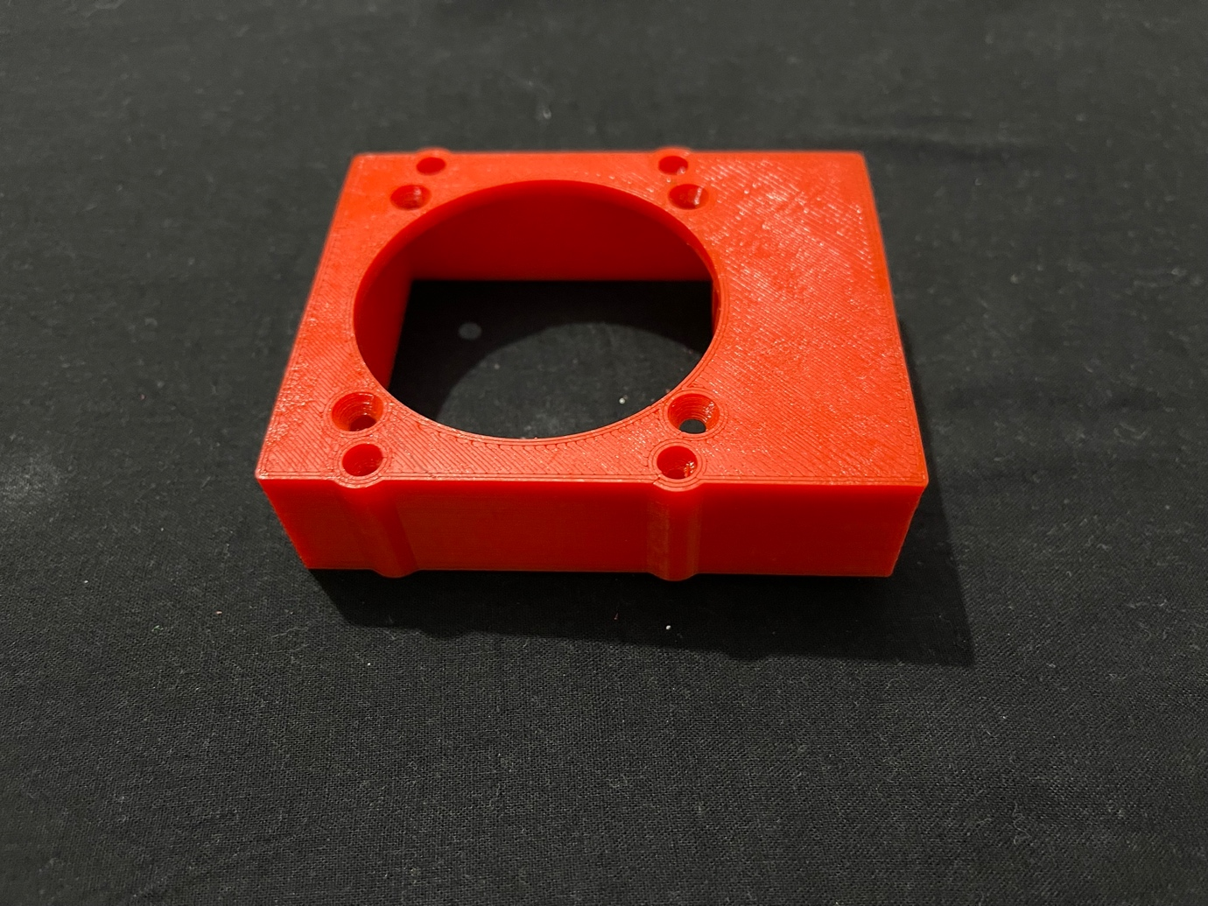

Photo-8

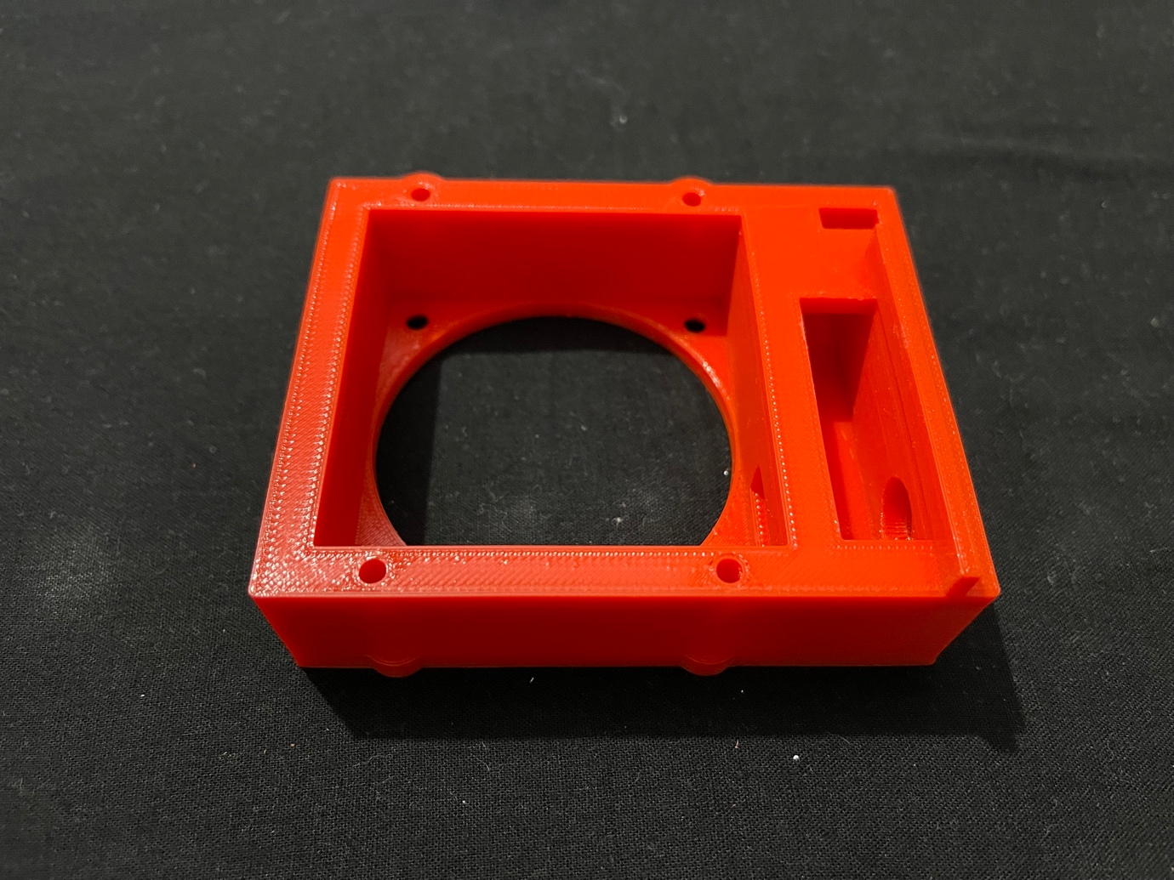

Photo-9

This is the part in which the fan will fit. The fan needs to be oriented in such a way that its wire exits towards the opening made inside for it. The wire comes out of the opening in the broad side. The broad side also has opening for the wires of peltier and the temperature probe. There is a projecting shelf which hold the temperature controller in its casing in its place. Part of the shelf may need to be taken out to allow space for the wires coming out.

There is a cut out on the side of the broad side for DC power Jack.

* 1. Part – 9

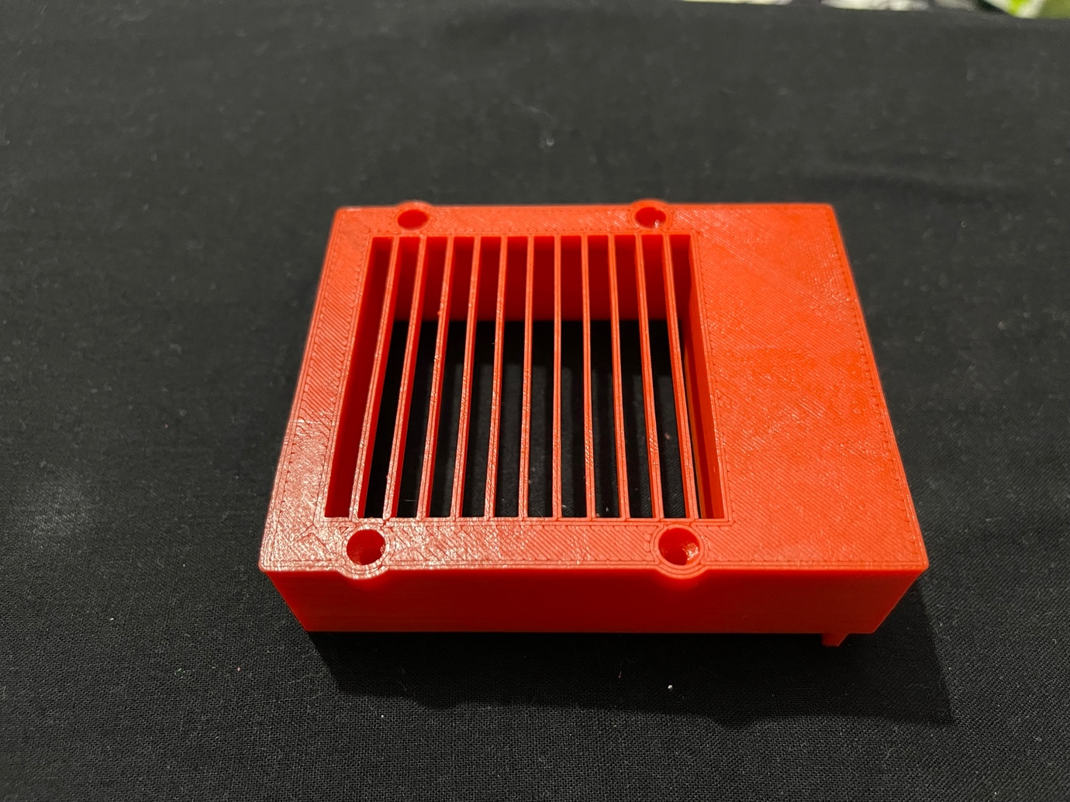

Photo-10

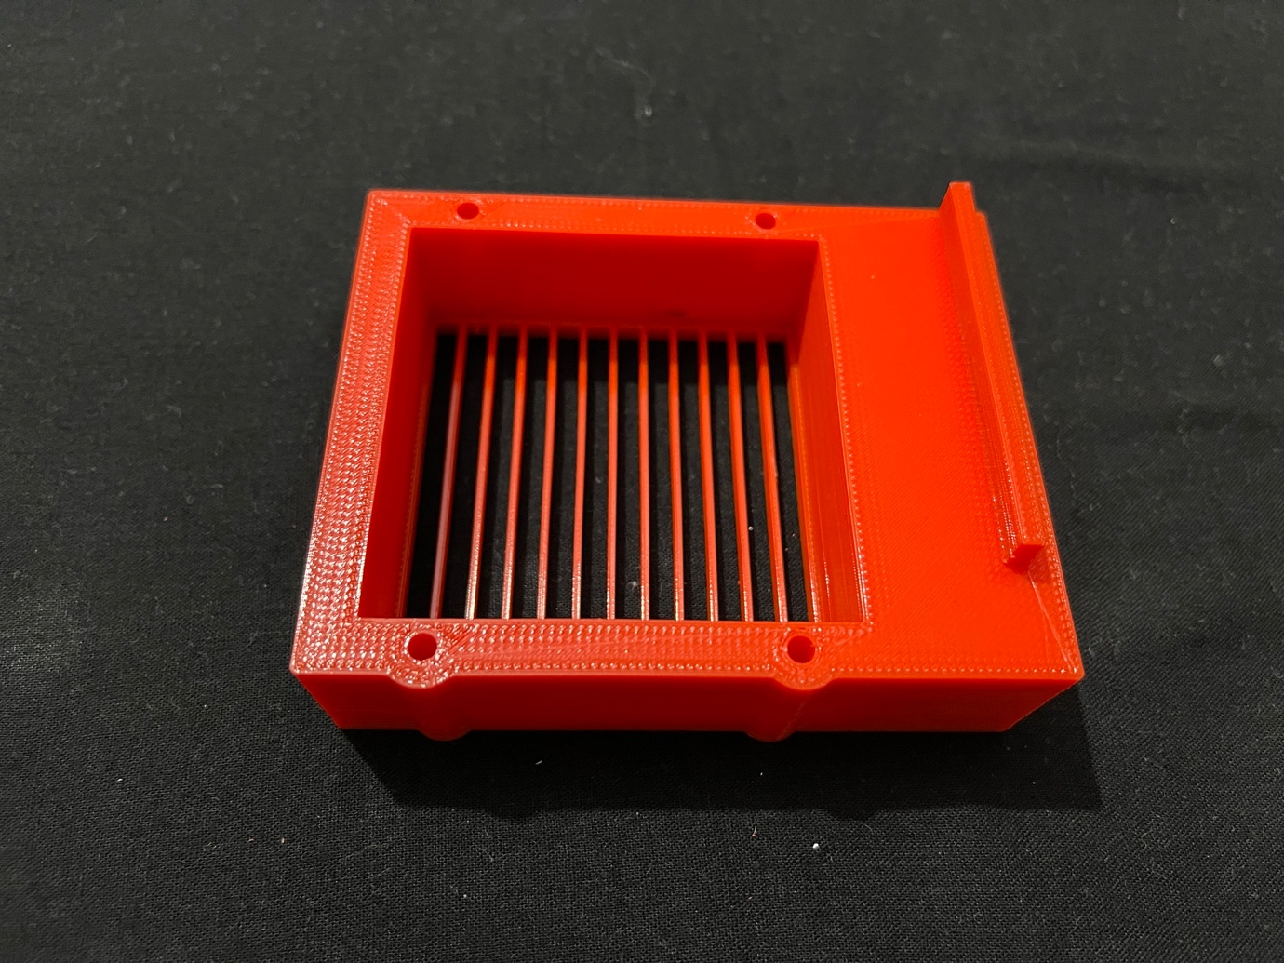

Photo-11

This is the exit for air. Its broad side has a shelf which holds the temperature controller in its casing in place.

* 1. Part -10

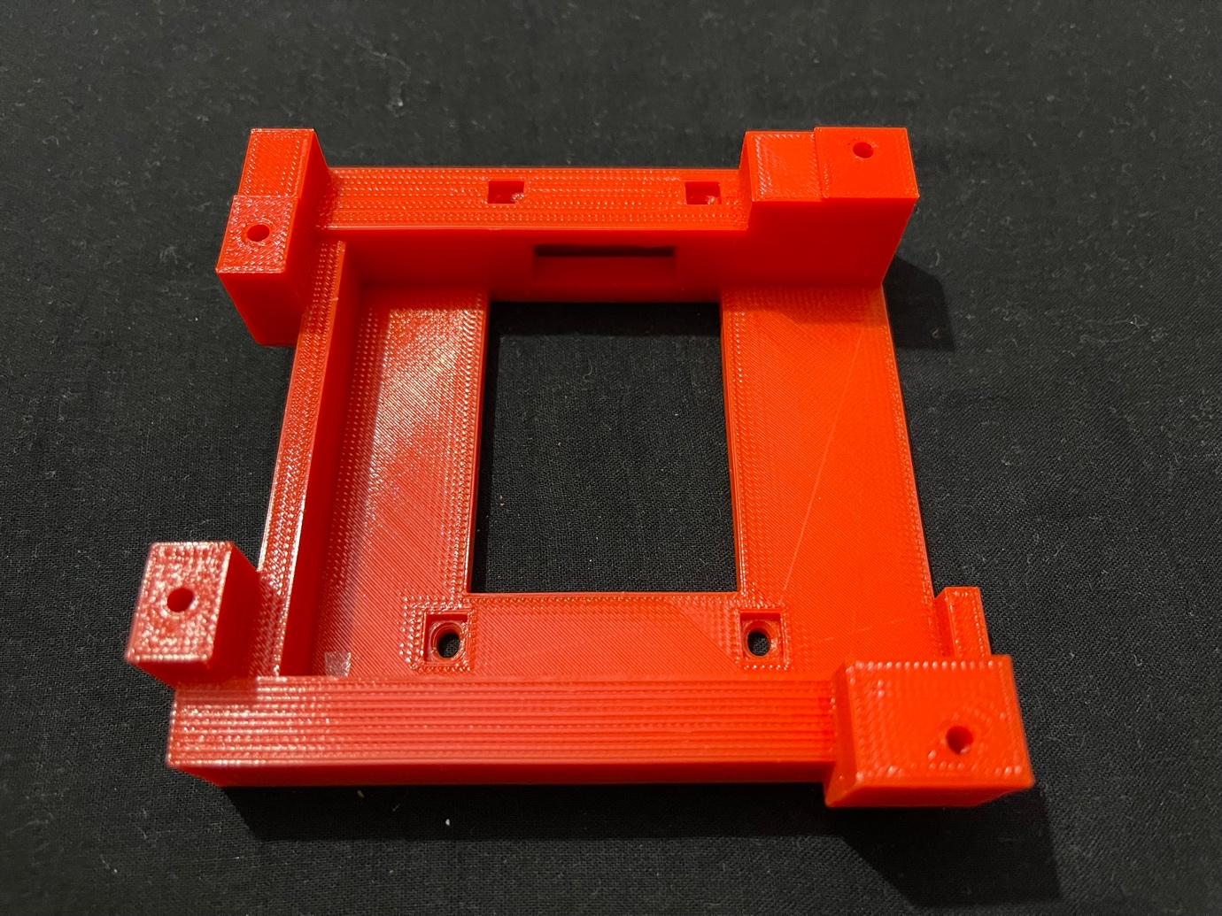

Photo-12

This part fits below the Part – 7. It has slot for the flat cable. The Argon case, with its roof taken out, fits inverted on this (in the view shown above).

* 1. Part – 11

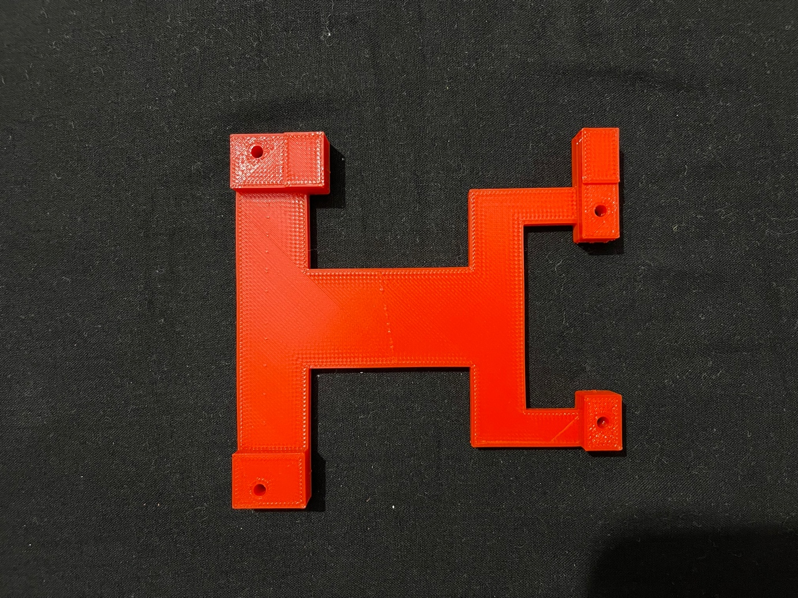

Photo-13

This is covers and holds the Argon case in place

* 1. Part – 12

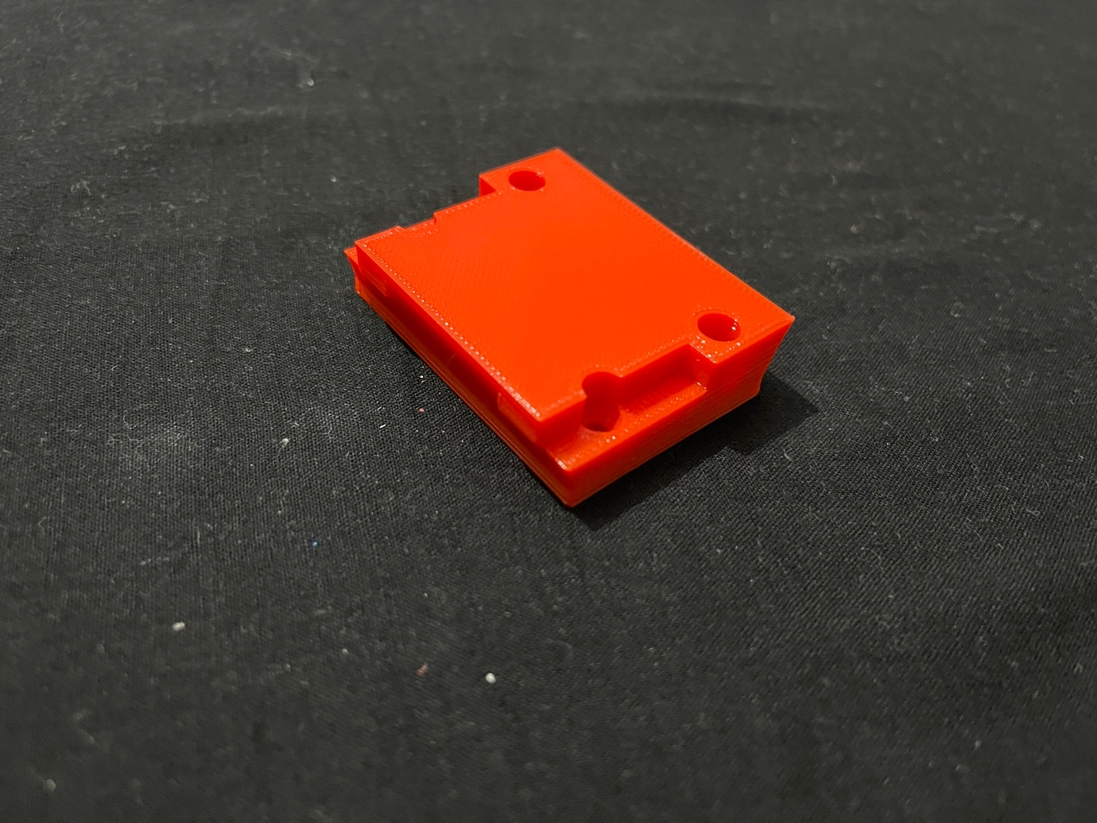

Photo-14

This is the 3D printed replica of the quick release plate of Manbily KM-O Ball Head (<https://www.amazon.in/gp/product/B07BHNN15D/ref=ppx_yo_dt_b_asin_title_o00_s01?ie=UTF8&psc=1>

<https://www.manbily.com/products/km-0-ball-head>).

1. Argon Neo Raspberry Pi – 4 case (<https://www.argon40.com/argon-neo-raspberry-pi-4-case.html>)

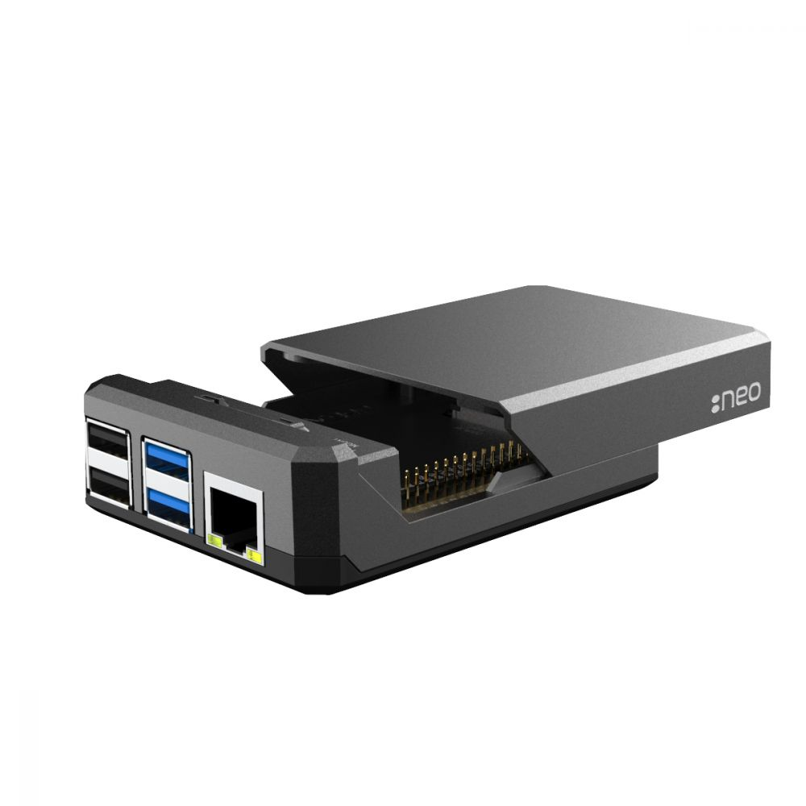

Photo-15

**Fitting The Parts Together**

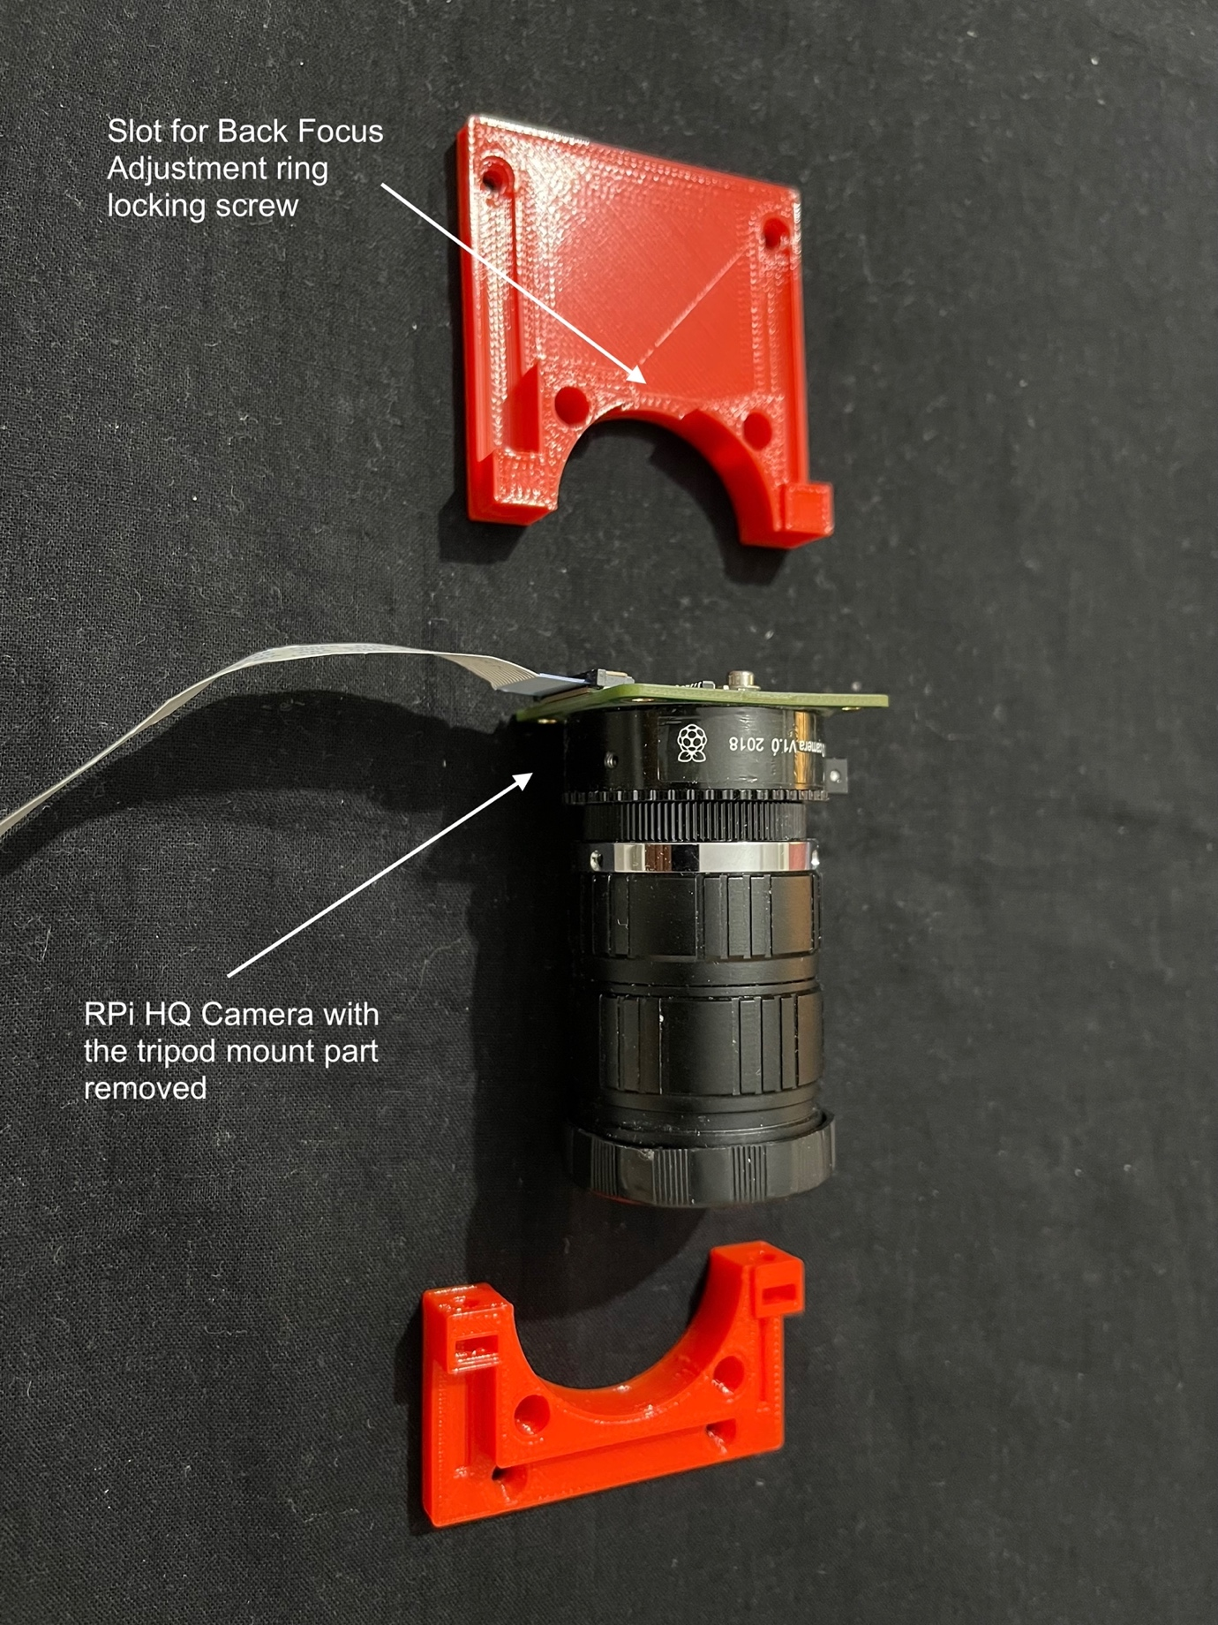

Photo-16

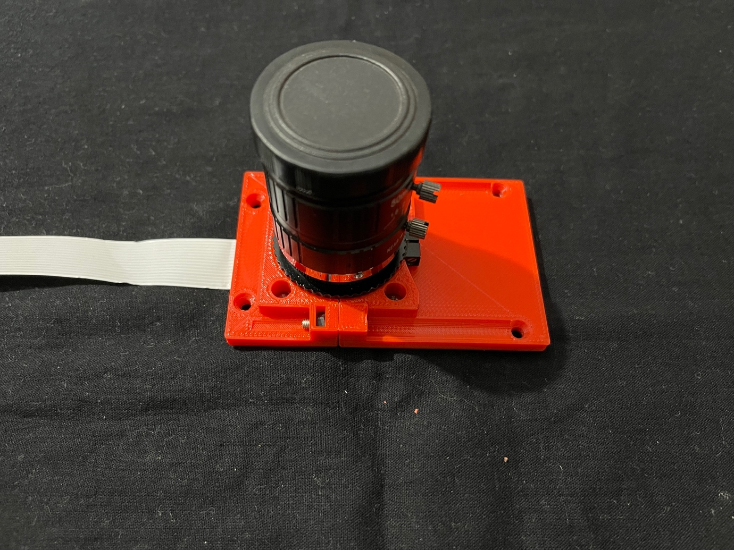

Photo-17

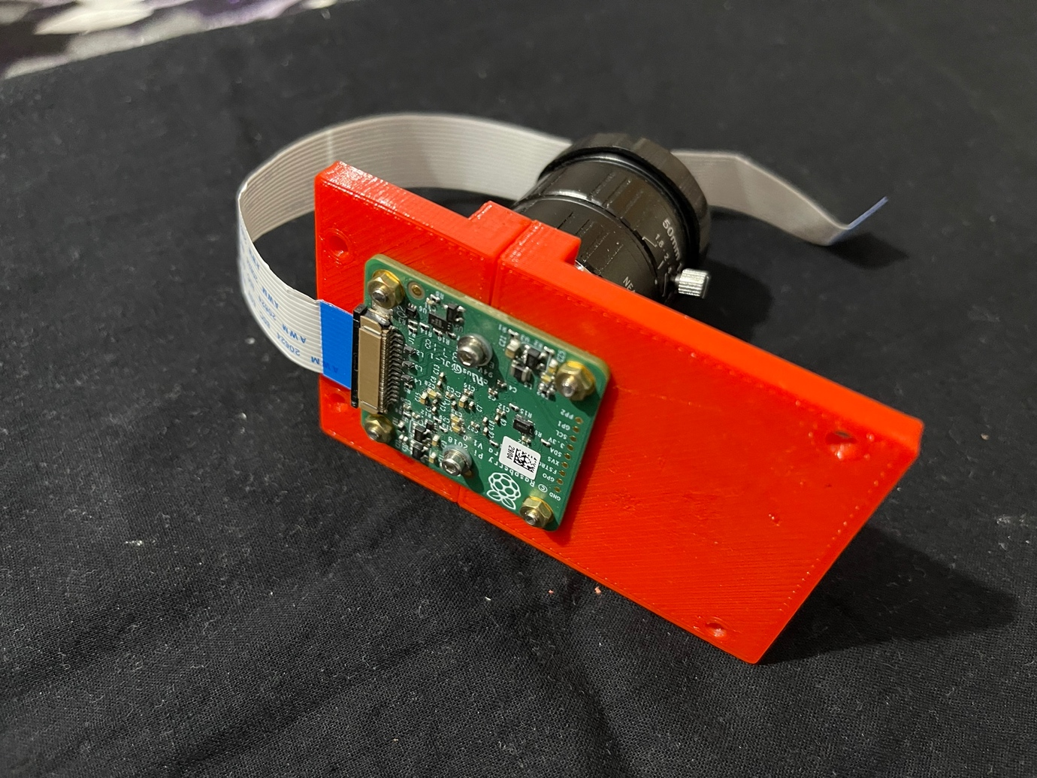

Photo-18

The Part 1 and 2 screwed together around the camera lens mount, below the back focus ring and above the PCB. Two M3 15mm screws with nuts fix the two parts of the plate together and four M2.5 6mm screws with nuts fix the PCB with the plates.

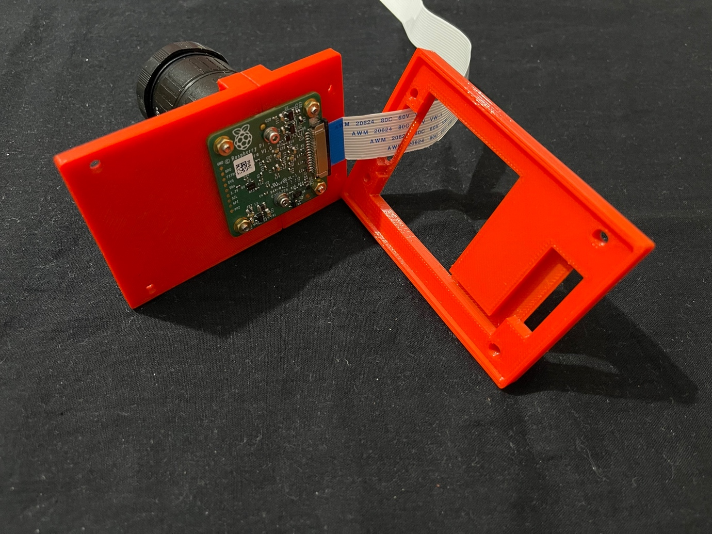

Photo-19

The part 3 in proper orientation. Before fitting the part 3, slide in the temperature probe, its wire going through the groove and into the slot. The temperature probe should be fixed with some thermal tape to the under surface of the PCB (must never put it directly on the PCB, it might short circuit some components) (See Photo-30). I had forgotten to place the temperature probe at this time and had to dismantle upto this part to place it.

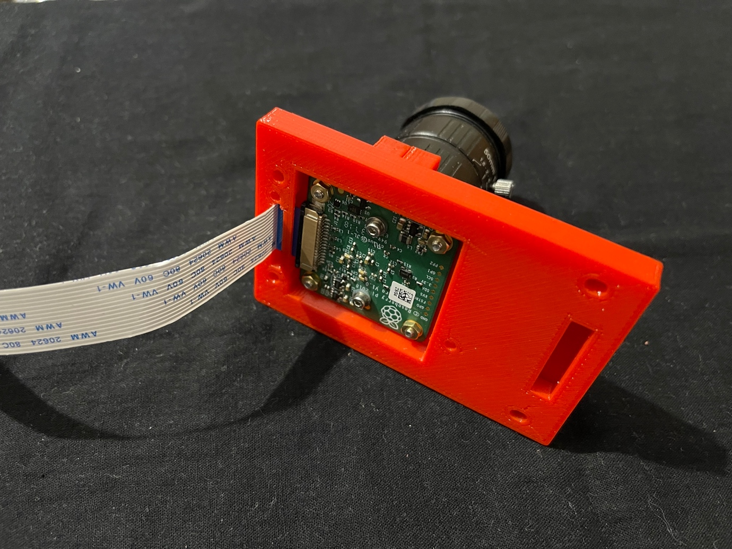

Photo-20

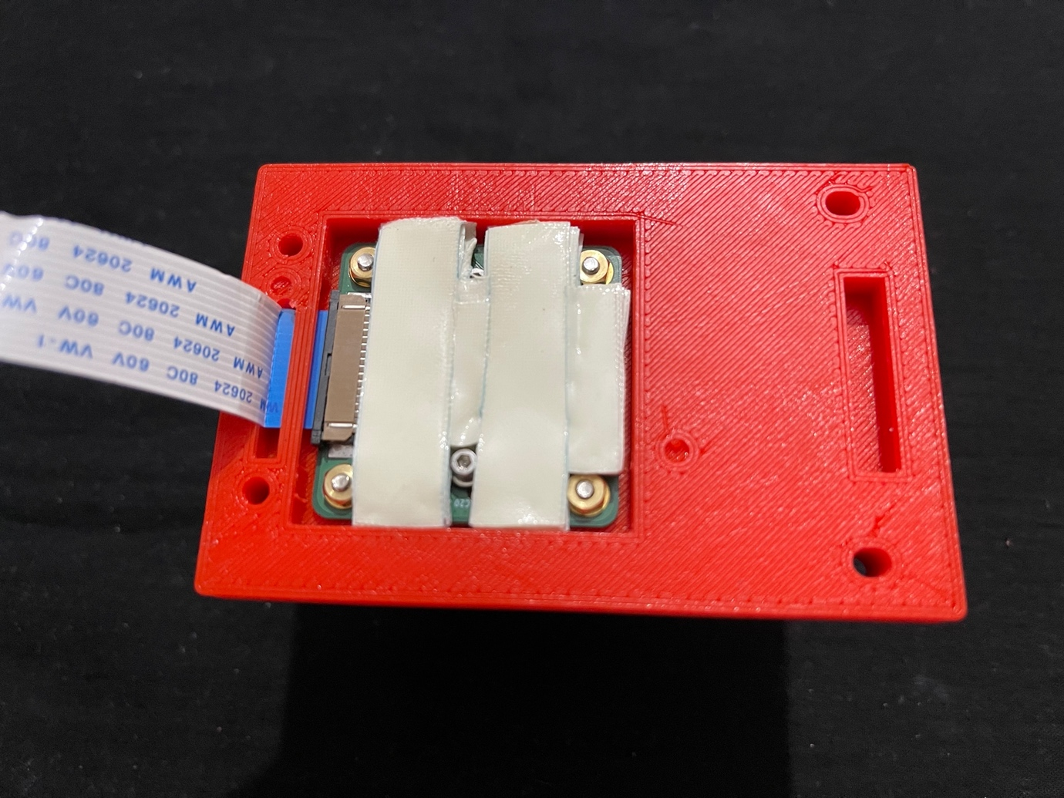

Photo-21

Two side sticking thermal conducting tape applied to underside of the camera pcb.

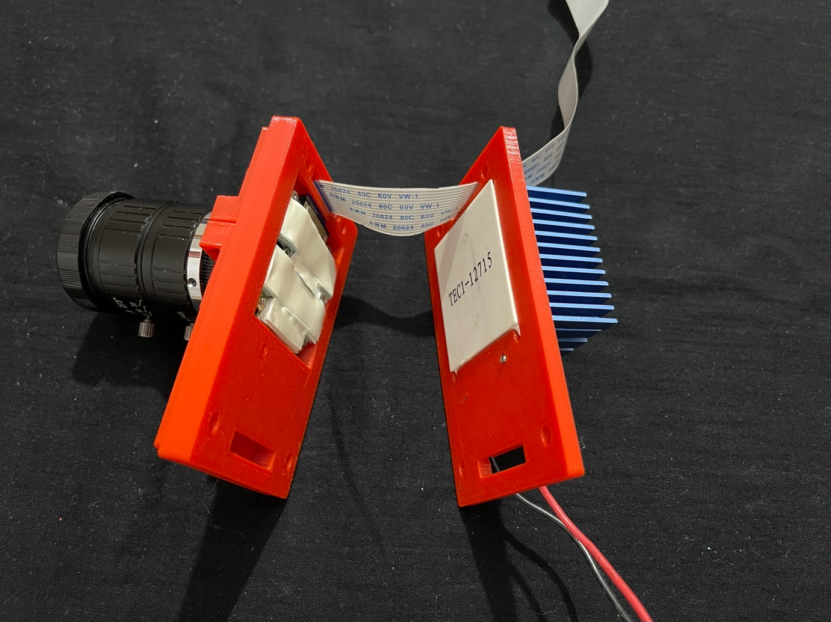

Photo-22

Parts 1-3 fitted with camera (yet to screw them together) and the part 5. When fixed together, the peltier sticks to the thermal tape on the undersurface of the camera PCB.

This turned out to be a disadvantage. As mentioned above when I had to dismantle these parts to place the temperature probe in place; while removing the peltier from the thermal tape, peltier got damaged and stopped working. So, I got another 2mm plate 3d printed (part – 4) and inserted an aluminium plate between the peltier and the thermal tape (more about it later).

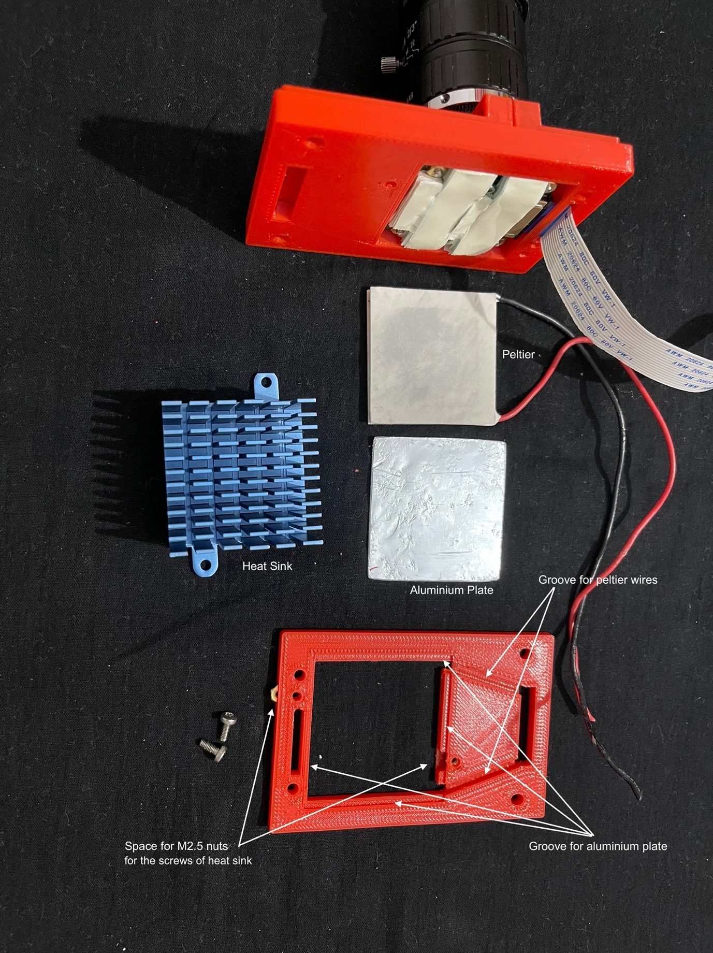

Photo-23

Fitting the peltier, 44x45x2mm aluminium plate and the heat sink to the part – 5.

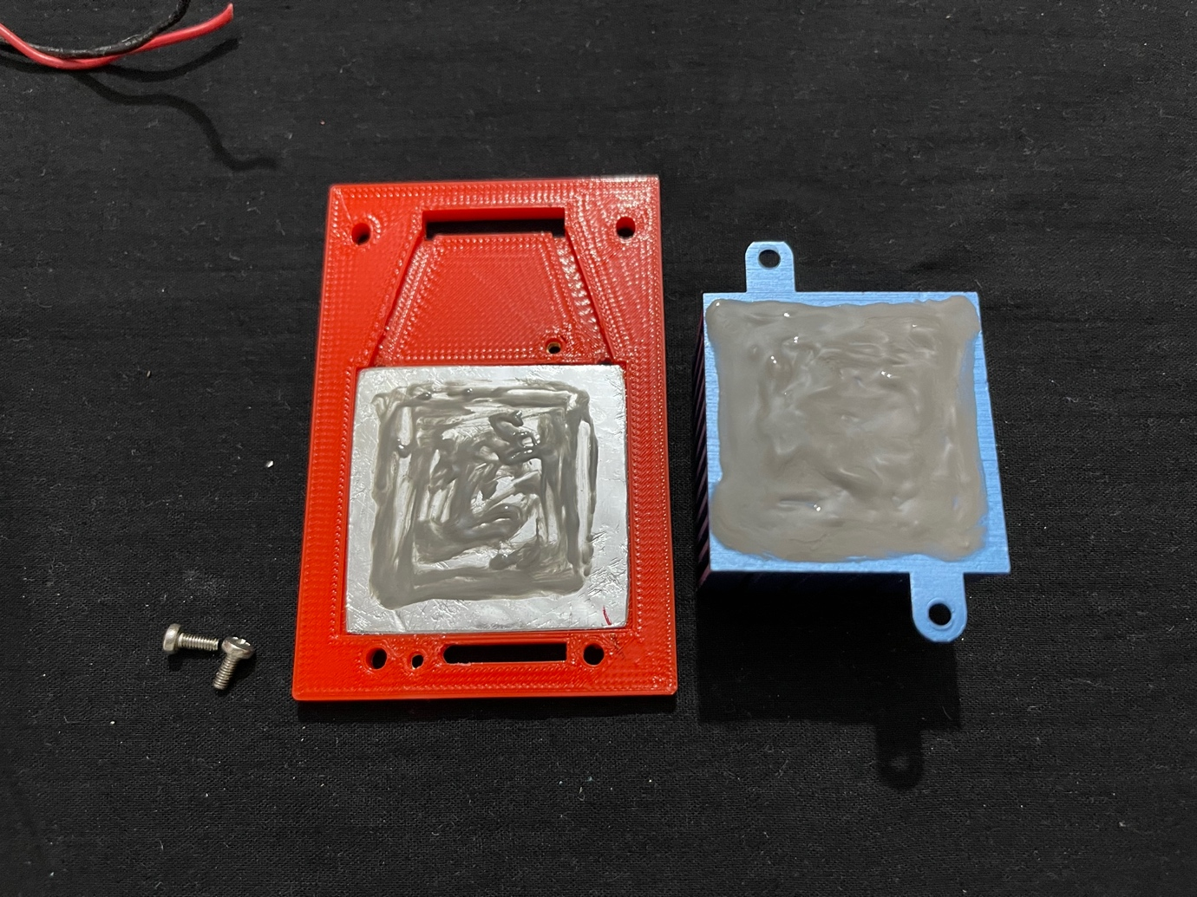

Photo-24

Aluminium plate placed into its groove, thermal paste applied to it and the heat sink. Heat sink screwed with two 6mm M2.5 screws. Nuts were already placed into the slots made for them. I had to file the edges of the aluminium plate to fit in the groove properly.

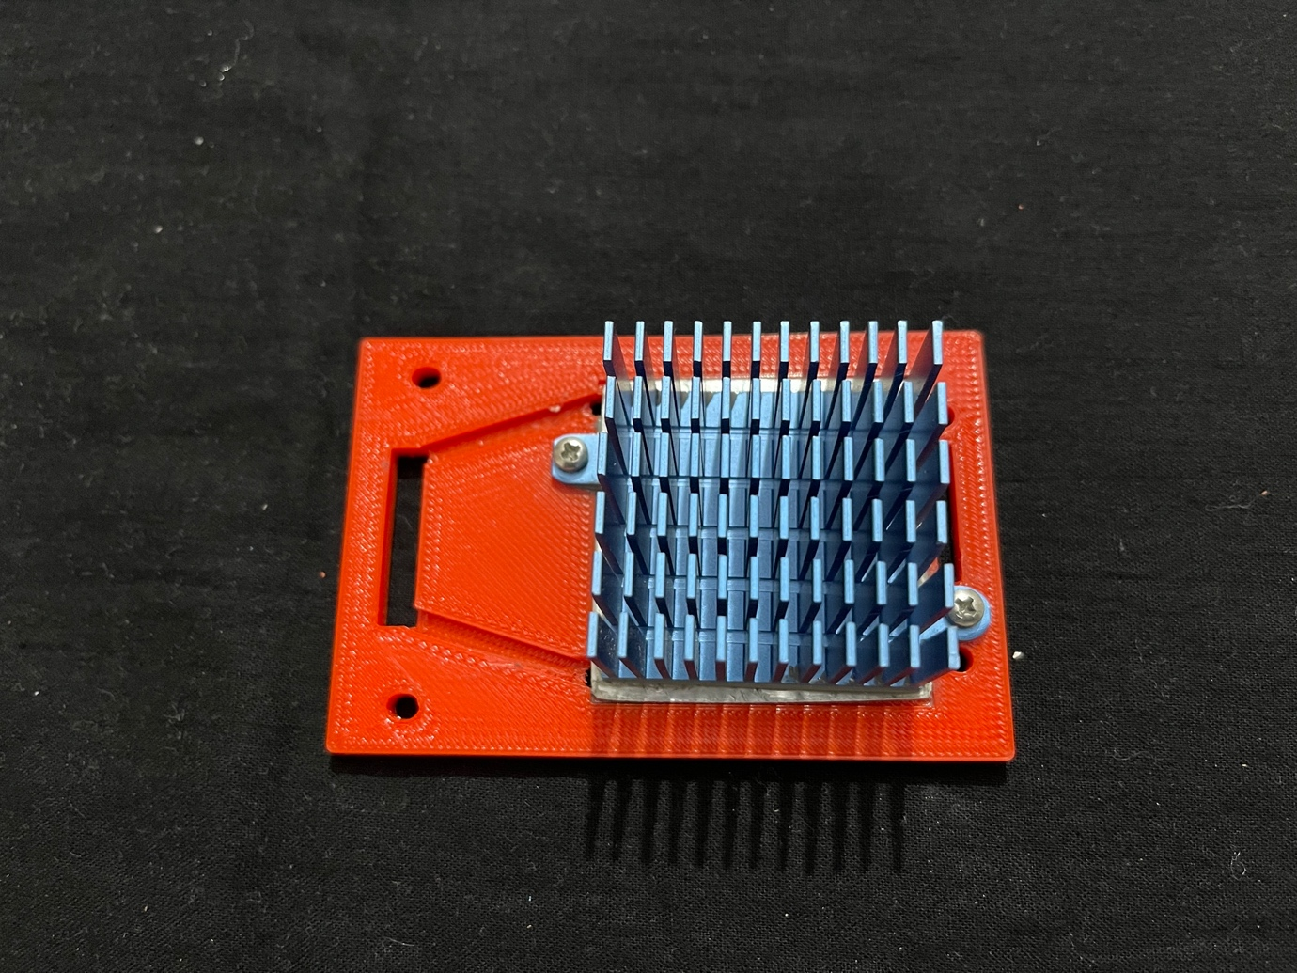

Photo-25

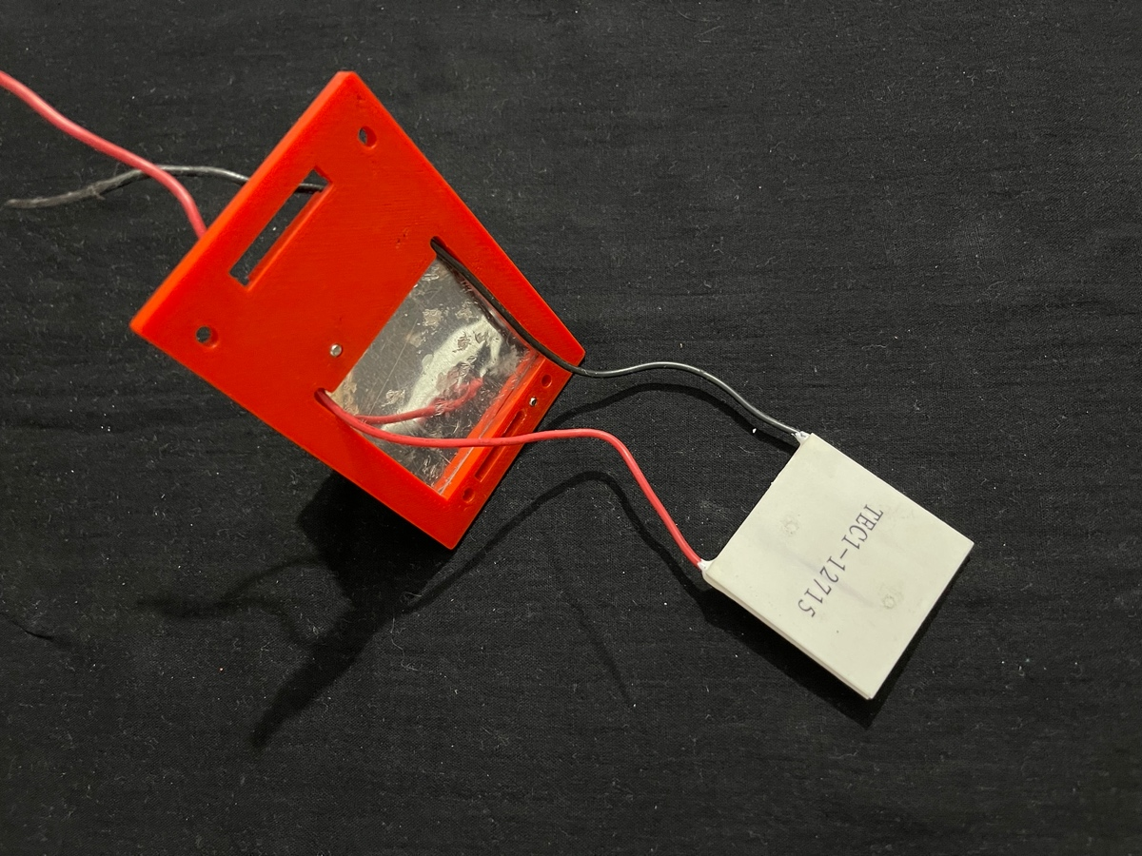

Photo-26

Peltier wires passed through the holes meant for them, making sure that the hot side of peltier comes in contact with the aluminium plate.

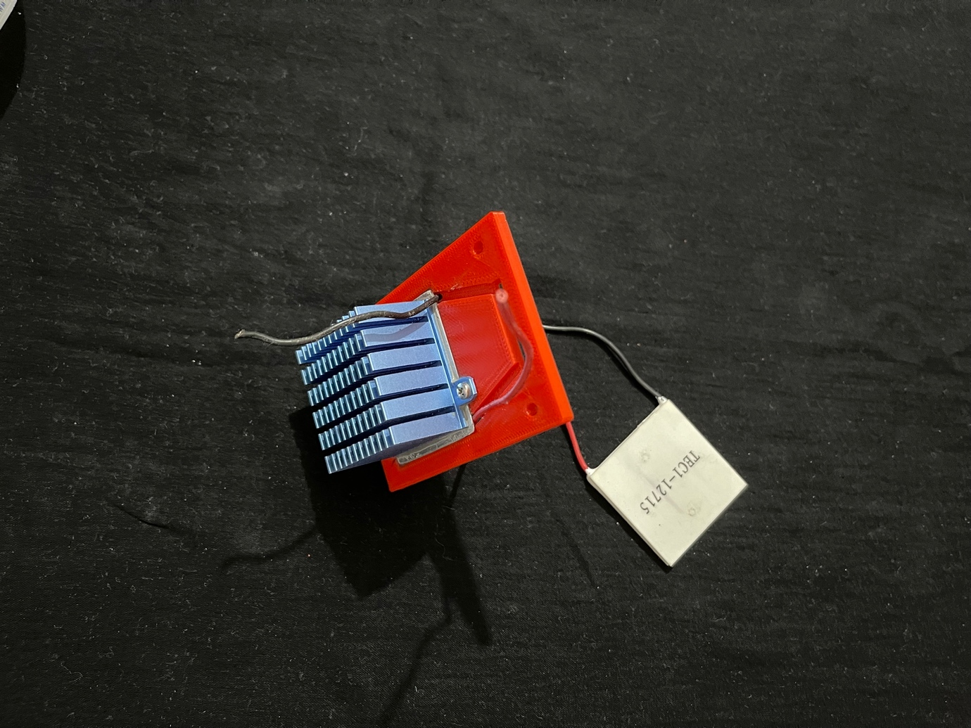

Photo-27

The peltier wires must be fixed in the grooves meant for them using a very small piece of double sided sticking tape.

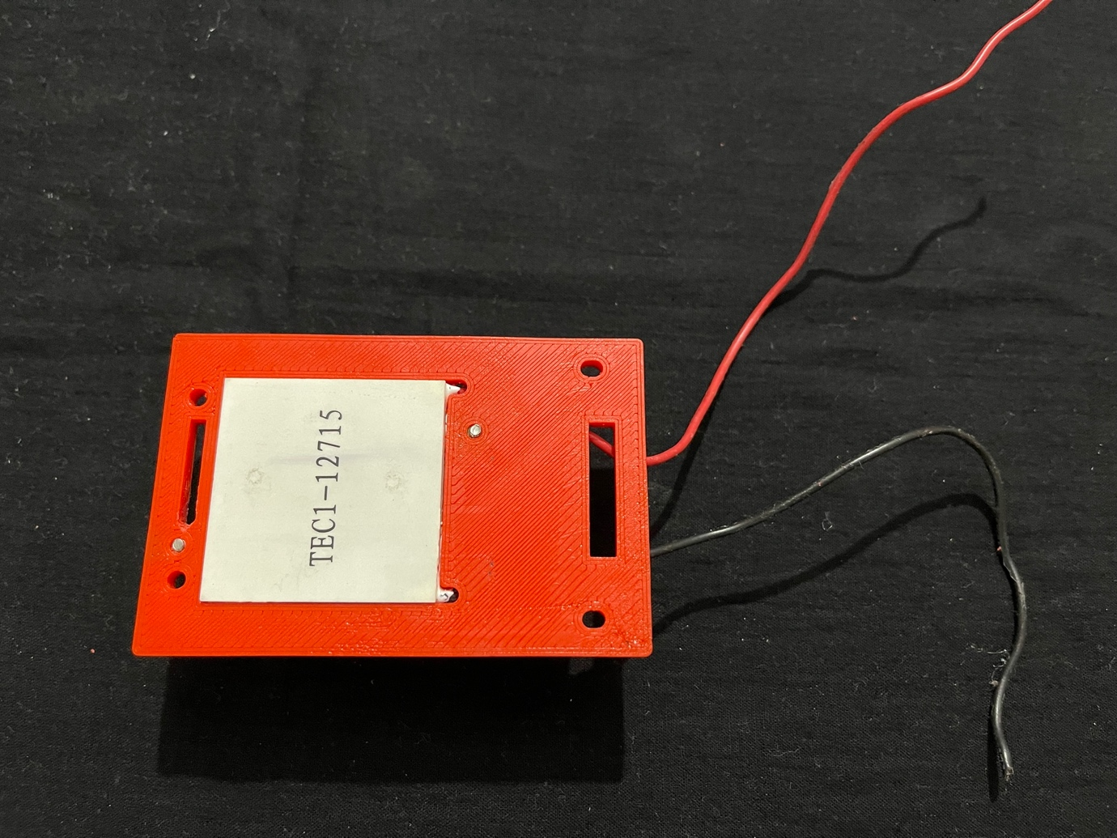

Photo-28



Photo-29

The Peltier side goes towards the camera side – the part – 4 and another aluminium plate comes between the parts shown in above photo (as clear from photos – 21, 22 and 23.). Plate with part no 4 was added later to the design to accommodate a 2mm thick 40mm x 40mm piece of aluminium sheet, because, if not done so, the peltier sticks to the thermal tape and it is very difficult to separate the pieces if needed. My peltier got damaged while I was separating it from the thermal tape (more about it later).

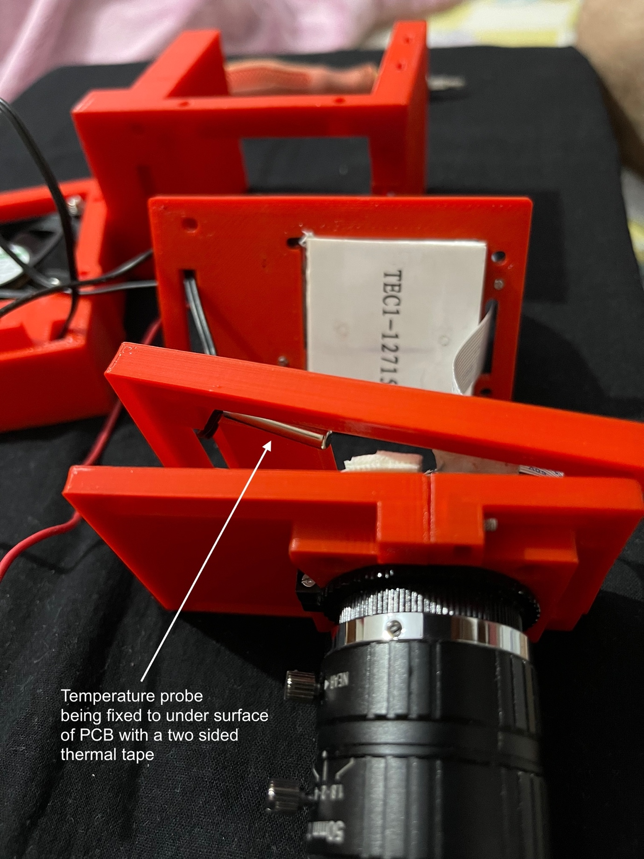

Photo-30

This is when I dismantled to get the temperature probe in place. Again, note that plate with part no 4 and an aluminium plate (40x40x2mm) will come between the part-3 and part-5 (more about it later). (Not seen in this photo). Parts have been separated to show their sequence.

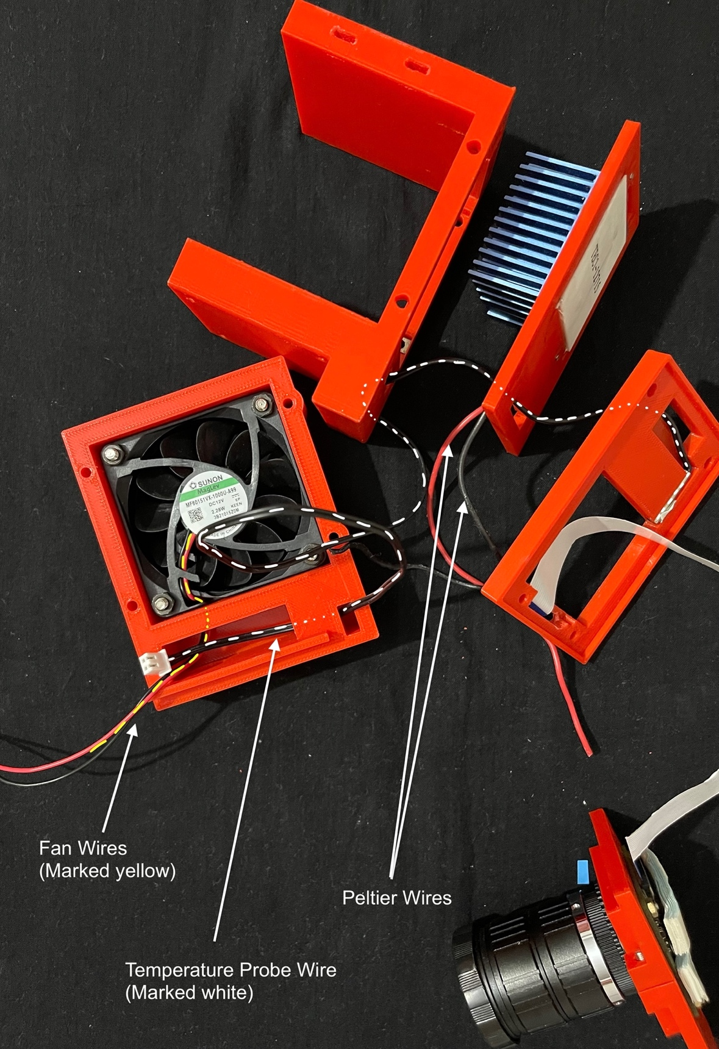

Photo-31

Passage of wires through various channels. The Peltier wires are yet not passed through the channel; they follow along the temperature probe wire. The fan has to be aligned in such a way that the corner from where the wire exits aligns with the passage created in the casing Part – 8.

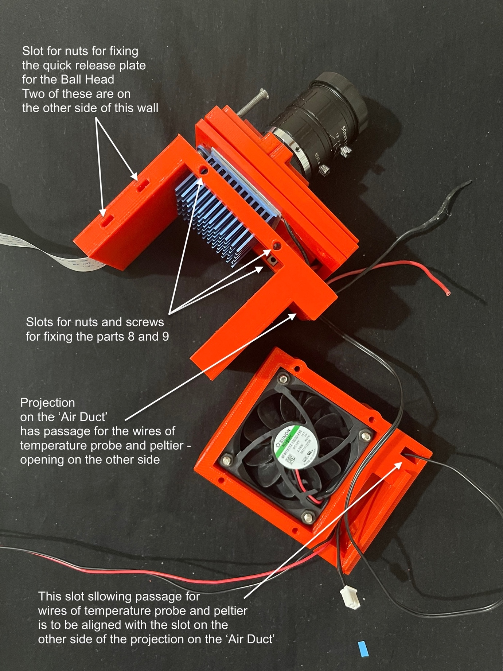

Photo-32

Part – 6 the ‘Air Duct’, as I call it, fits next. The parts 1/2, 3, 5 and 6 are to be fixed using four 45mm M3 screws. The slots for their nuts can be easily made out. Some of the nuts were found to be thicker than the 2mm slots created and had to be filed down to fit. Before fixing them, make sure to place the nuts for the screws (M3) to fix the Parts 8 and 9 in the two slots which are going to get obscured by the heat sink – see above picture (photo-32).

Before fixing the Parts – 8 and 9 to the sides of Part – 6, do insert the nuts for the quick release plate in the slots depicted in the above picture (photo-32) because these won’t be visible after these are attached. Make sure the nuts have gone in properly and screws can screw on in them.

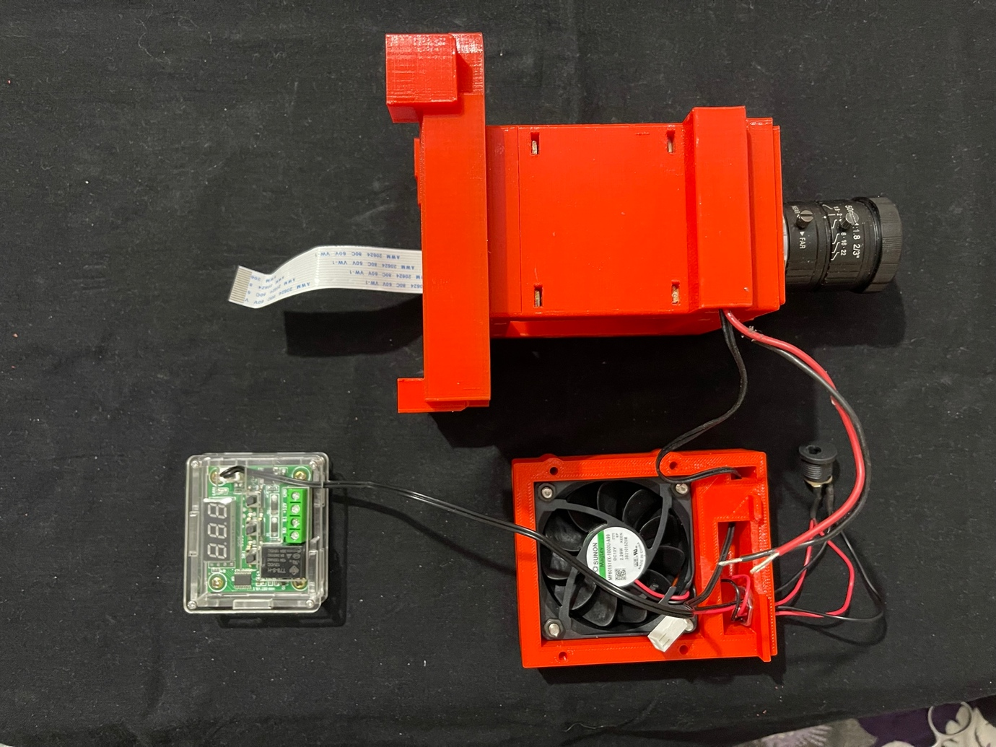

Photo-33

Screw in the DC Power Socket before fixing the fan before screwing it in place. In this picture the Parts 7 and 10 have already been fixed to the Part – 6 with four 45mm M3 screws. This can be done at this time or after fitting the Parts – 8 and 9.

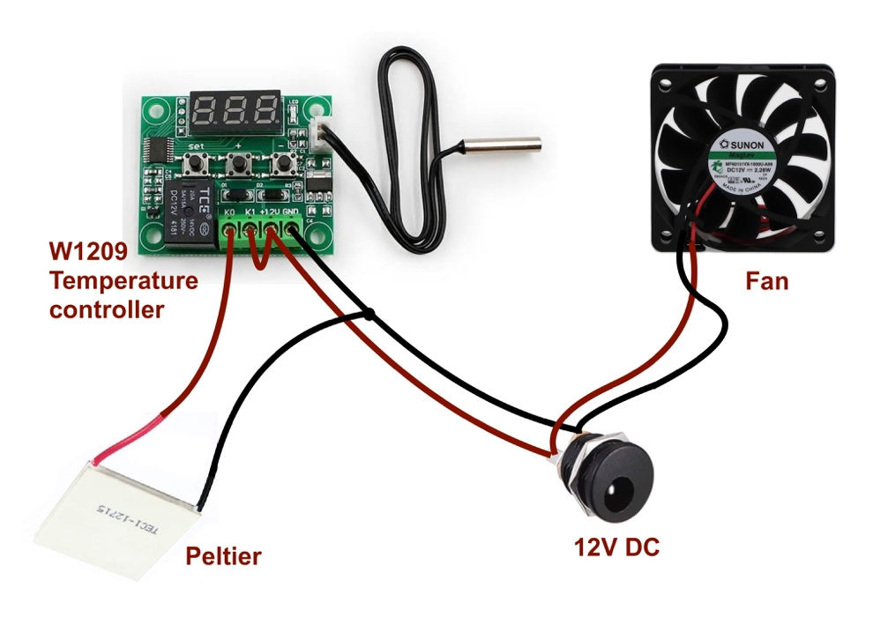

Photo-34 Circuit diagram

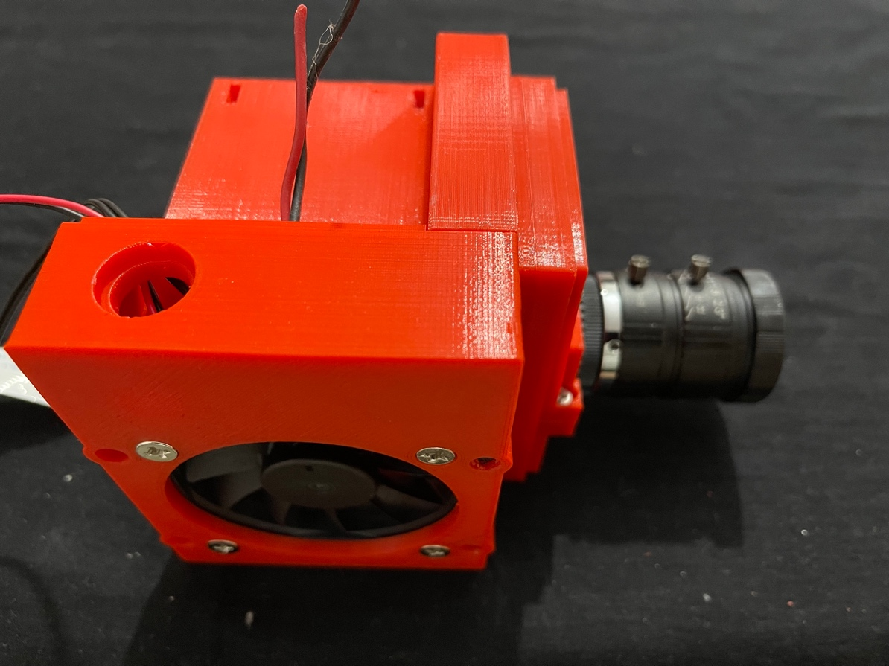

Photo-35

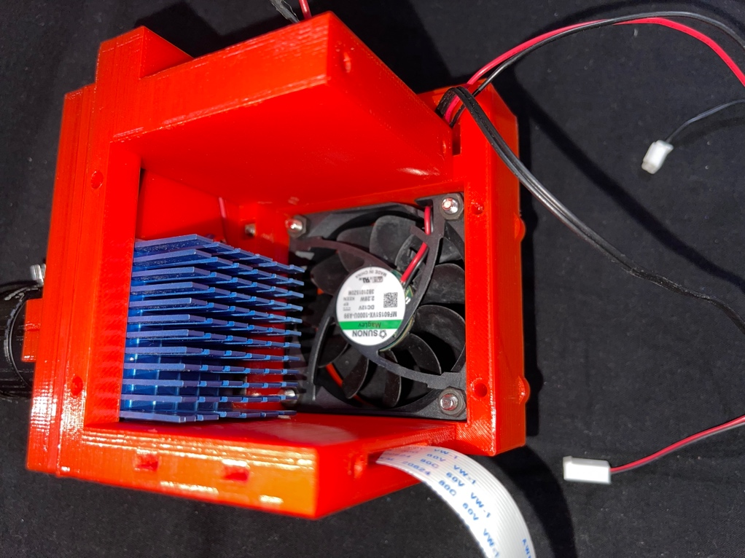

Photo-35

Important note – as mentioned above the power socket should be fixed before screwing in the Part – 8.

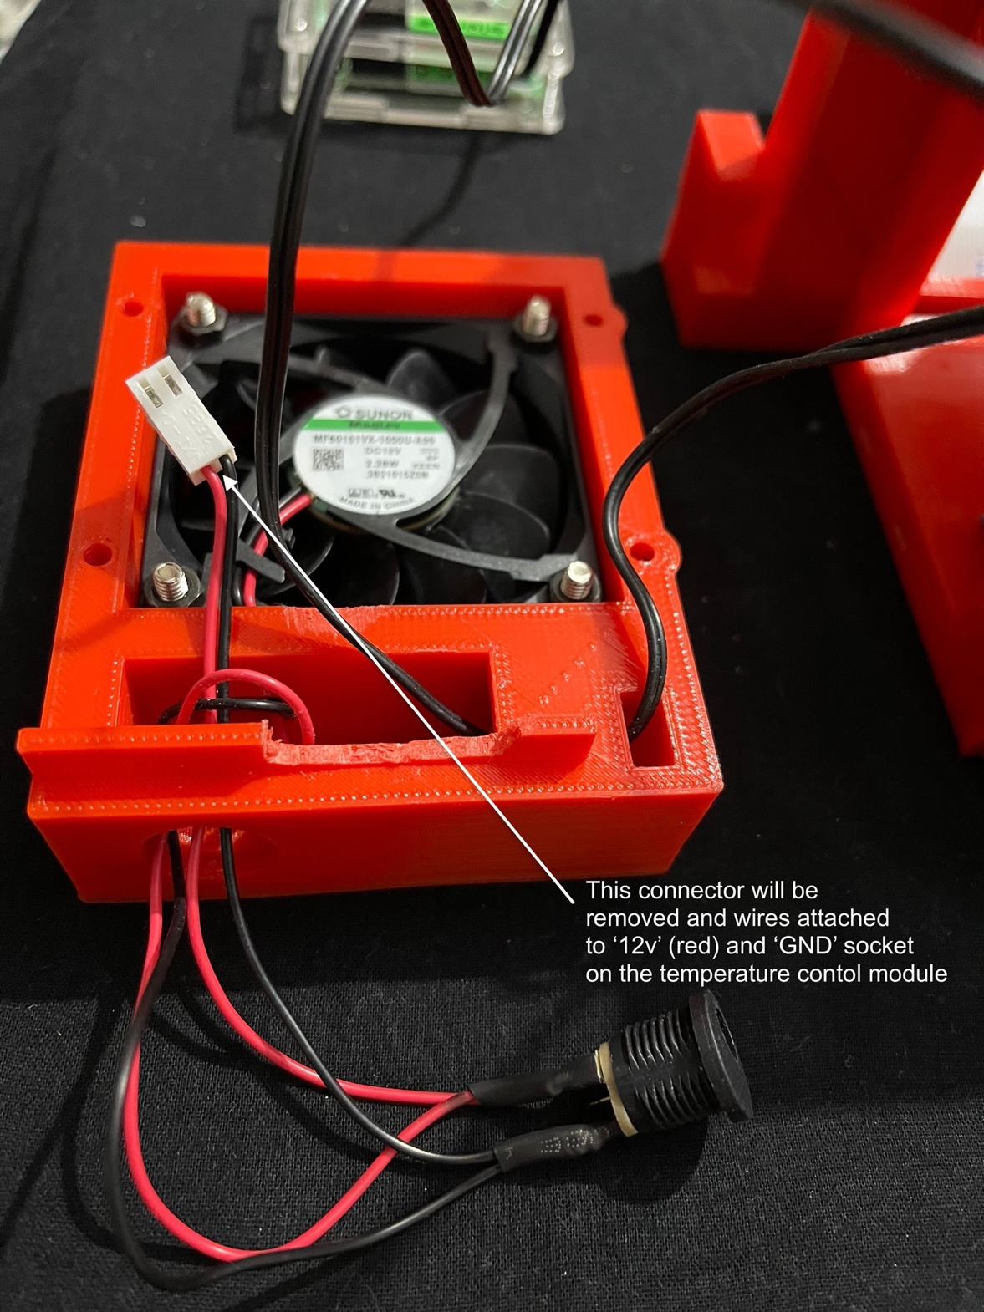

Photo-36

The shelf has been removed in part to make way for the wires.

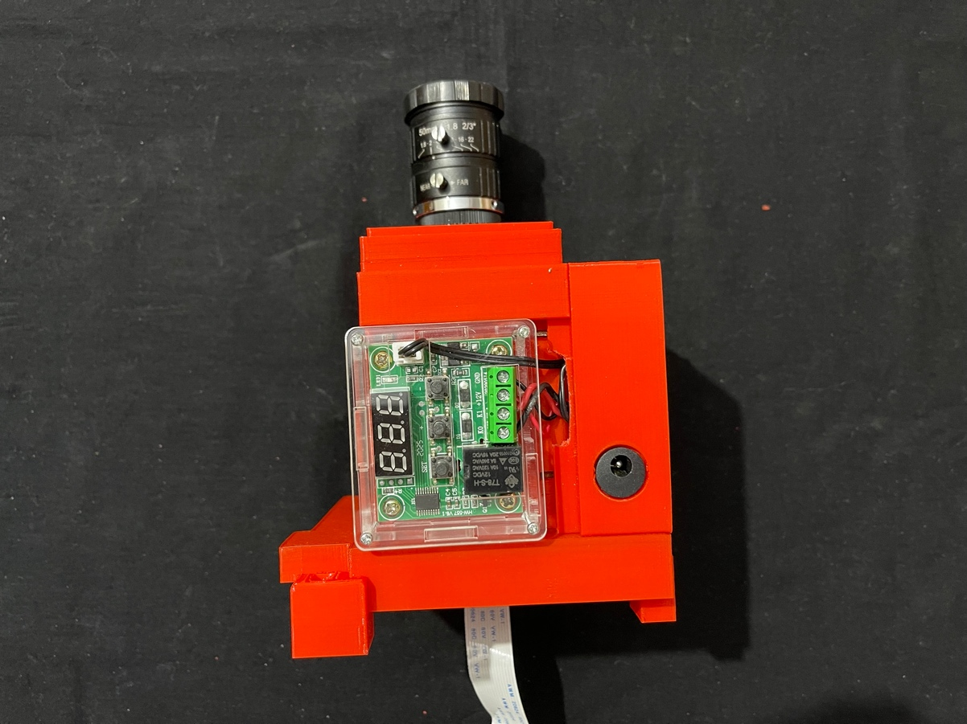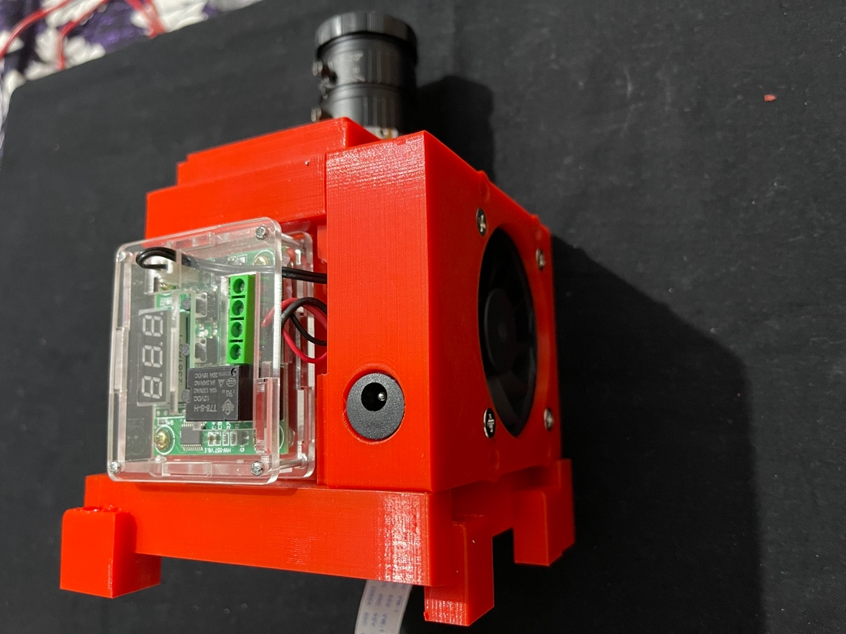 Photo-37

All the wires attached. The bottom plate of the acrylic case of W1209 slides under the shelf on the Part – 8 and also the Part – 9.

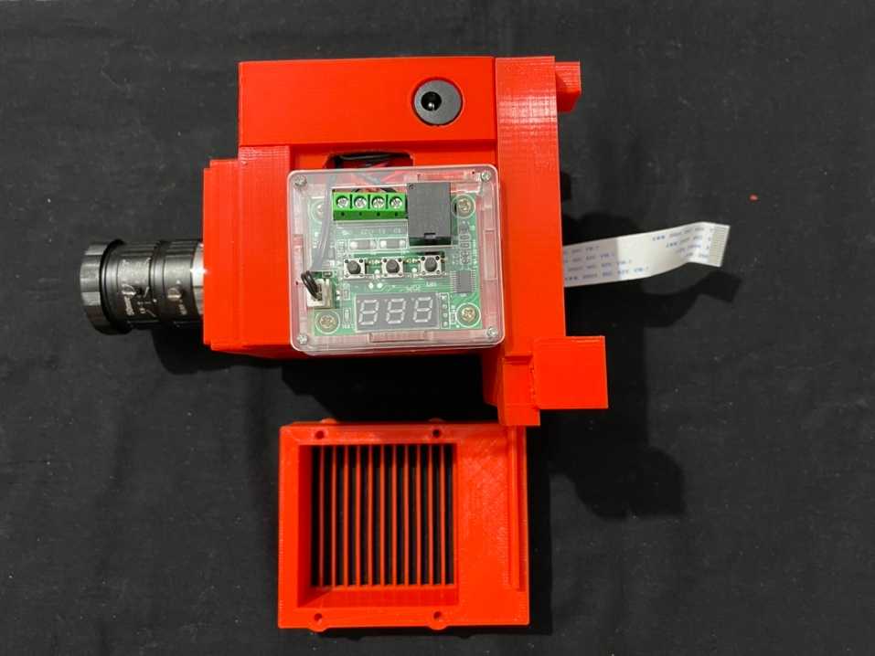

Photo-38

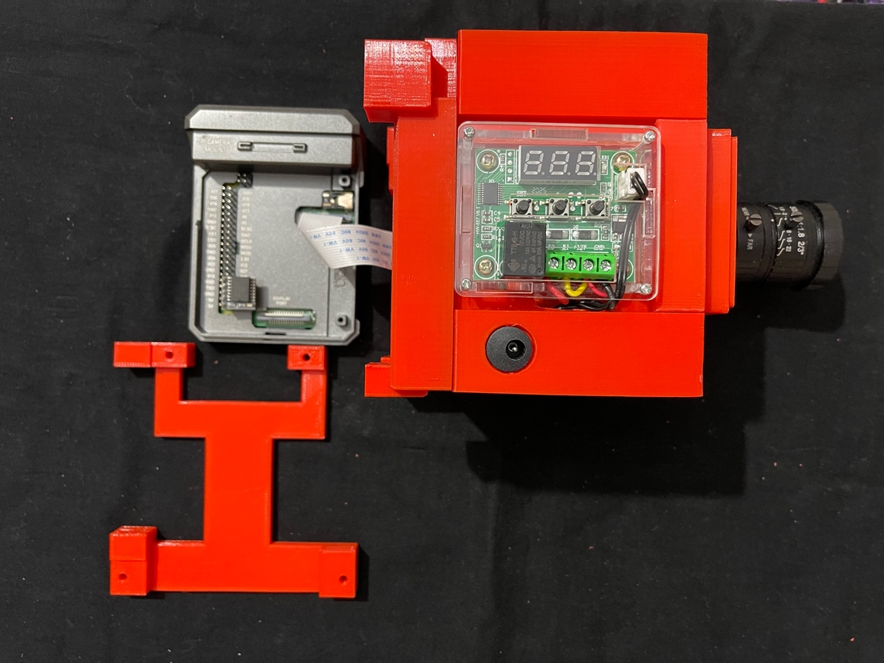

Photo-39

The camera flat cable connected to the camera portal in the RPi, which has already been fitted in the Argon Neo case (Lid removed). The case is properly oriented in the above picture for the case. The final bottom plate, the Part 11 ready to be fixed with four 30 mm M3 screws.

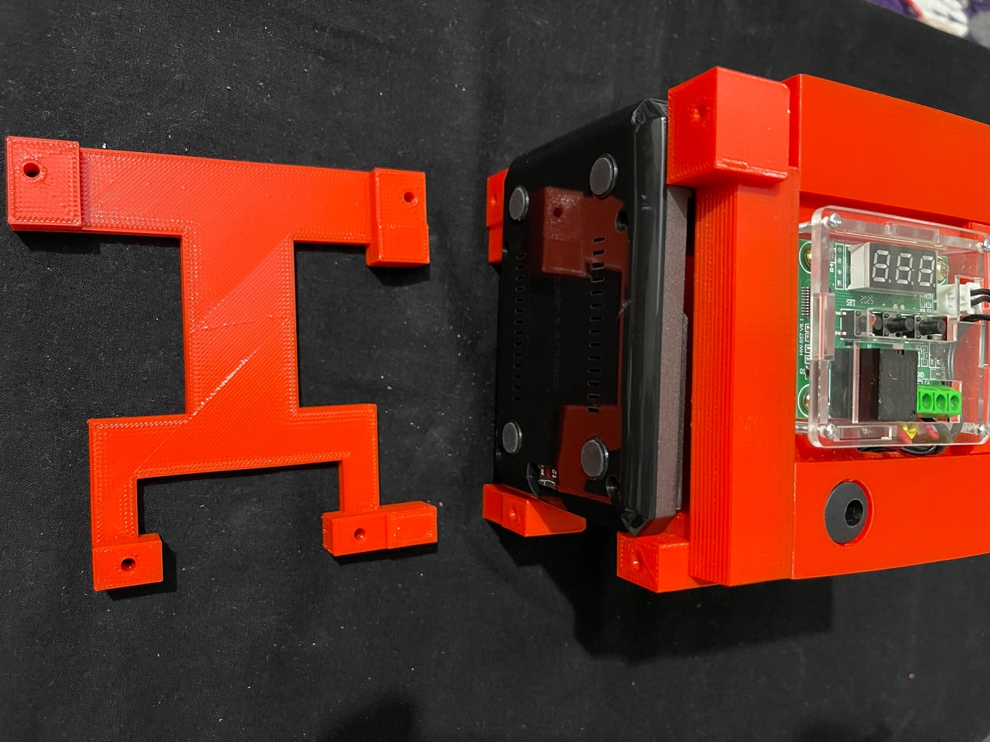

Photo-40

The RPi in the Argon Neo case placed in the case. Note that the rubber feet are attached to the bottom of the case. These make the fitting of the final restraining plate secure and tight.

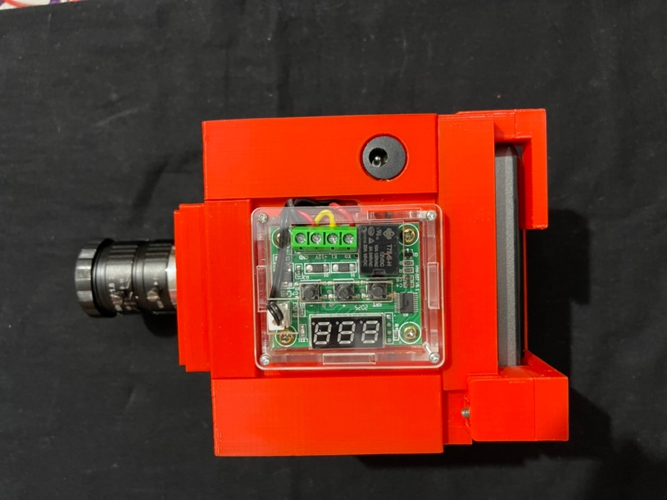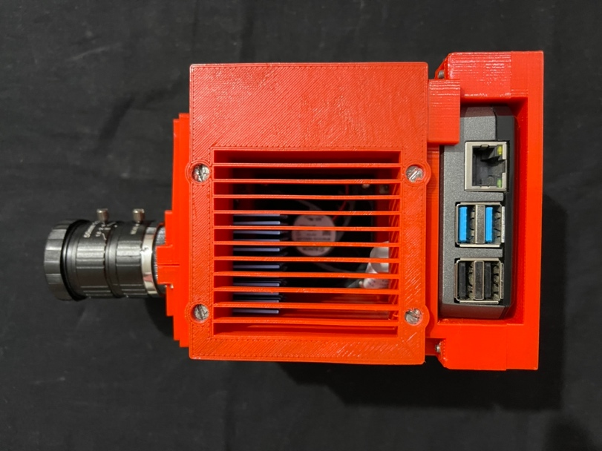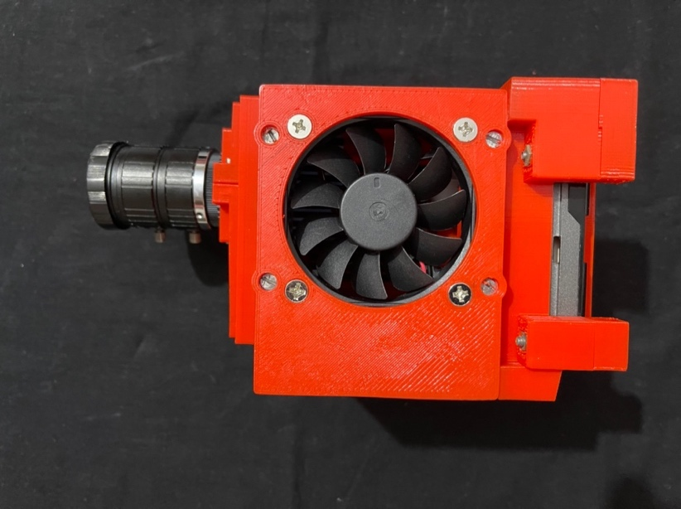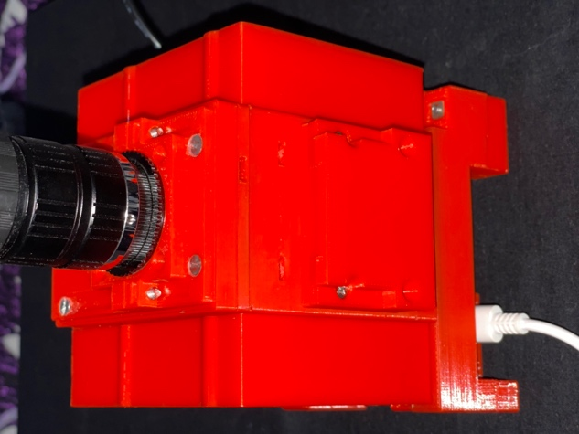

Photo-41

Finally, Part – 12, the quick release plate replica for the ball head is screwed in place with four 30mm M3 screws (bottom right in above photo).

**Note:**

As I mentioned above, I made a change, actually an addition to the above design to allow easy separation of the parts above peltier from those below.

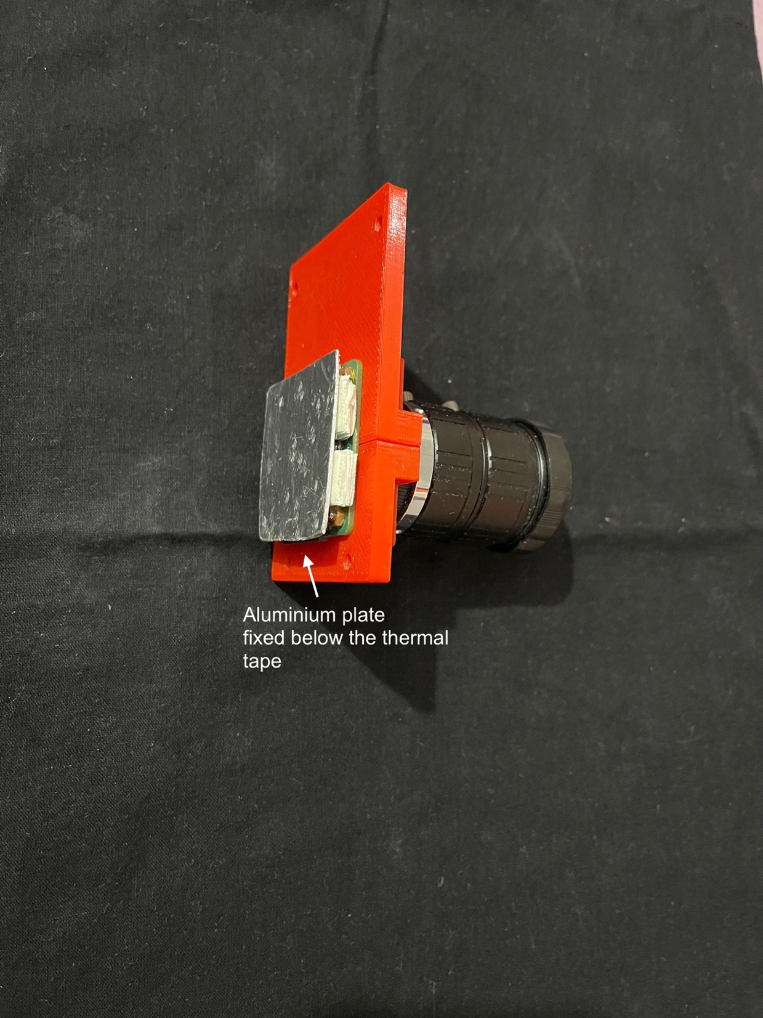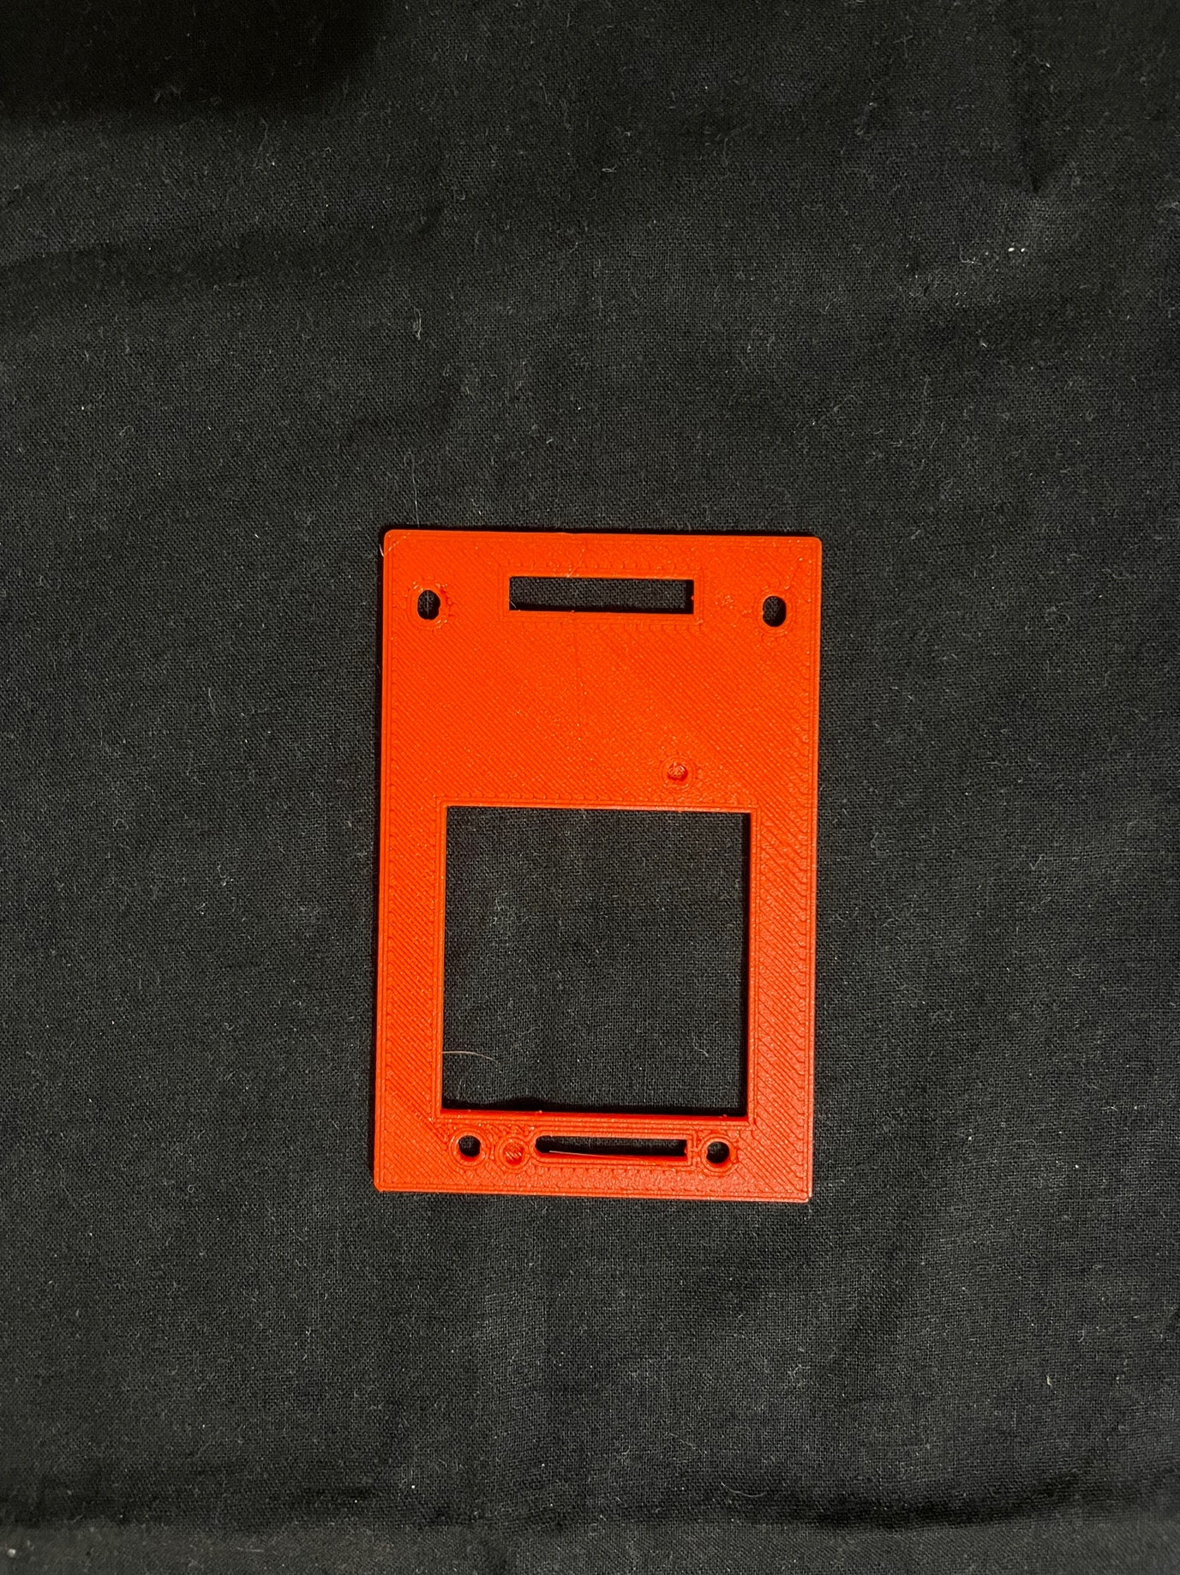

Photo-42

40x40x2mm aluminium plate fixes to the thermal tape and fits into the central square cut out in the plate with part no – 4.

The Part – 4 is placed between the parts 3 and 5.

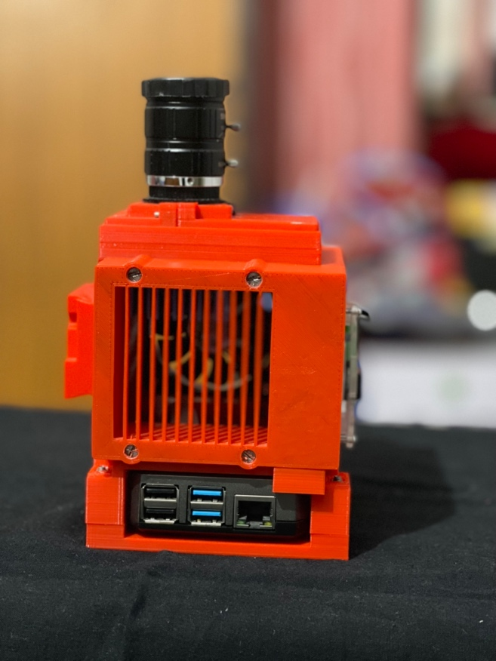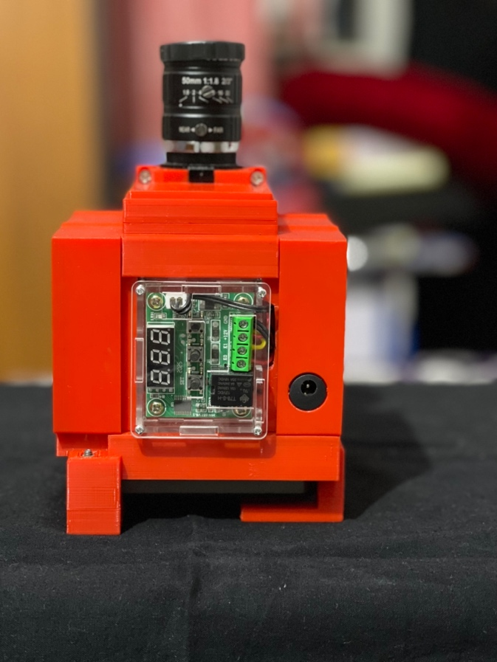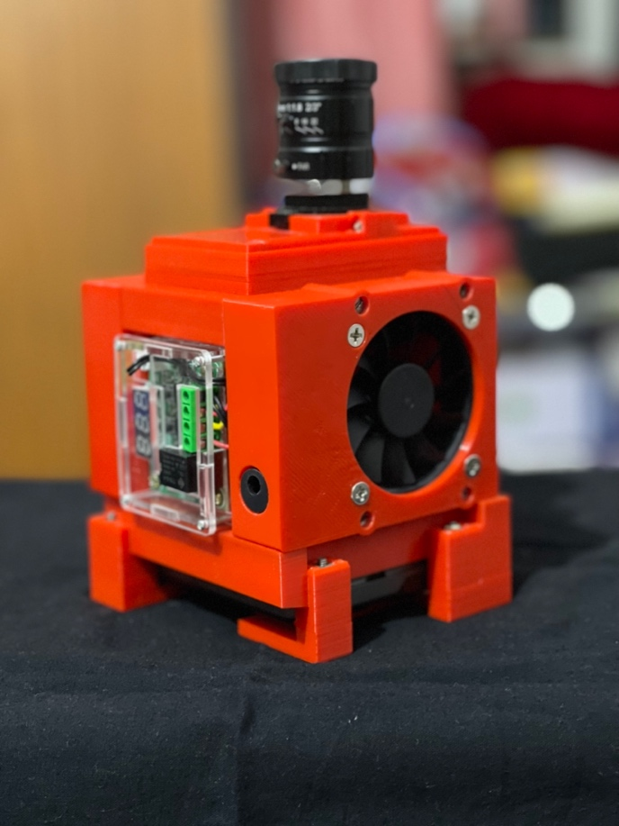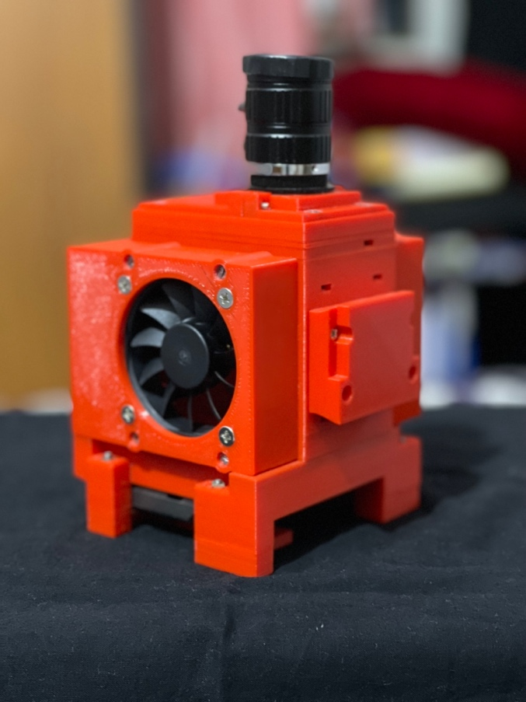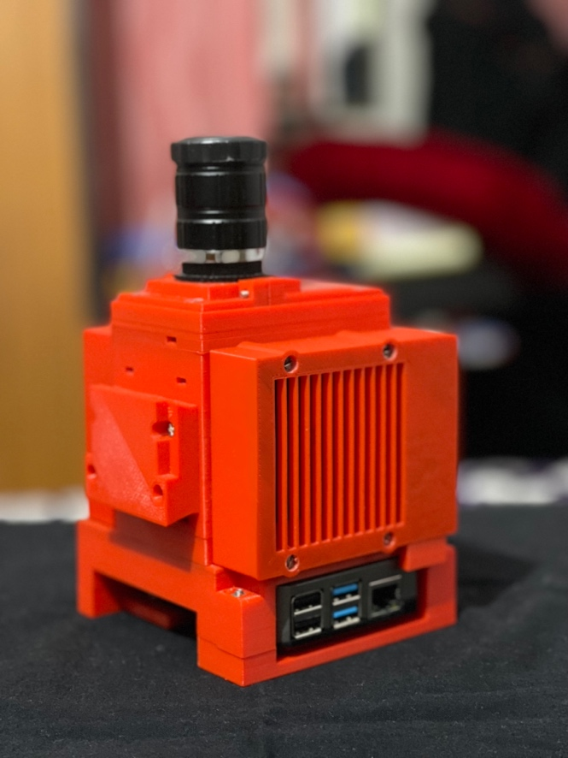

Photo-43 – Final product

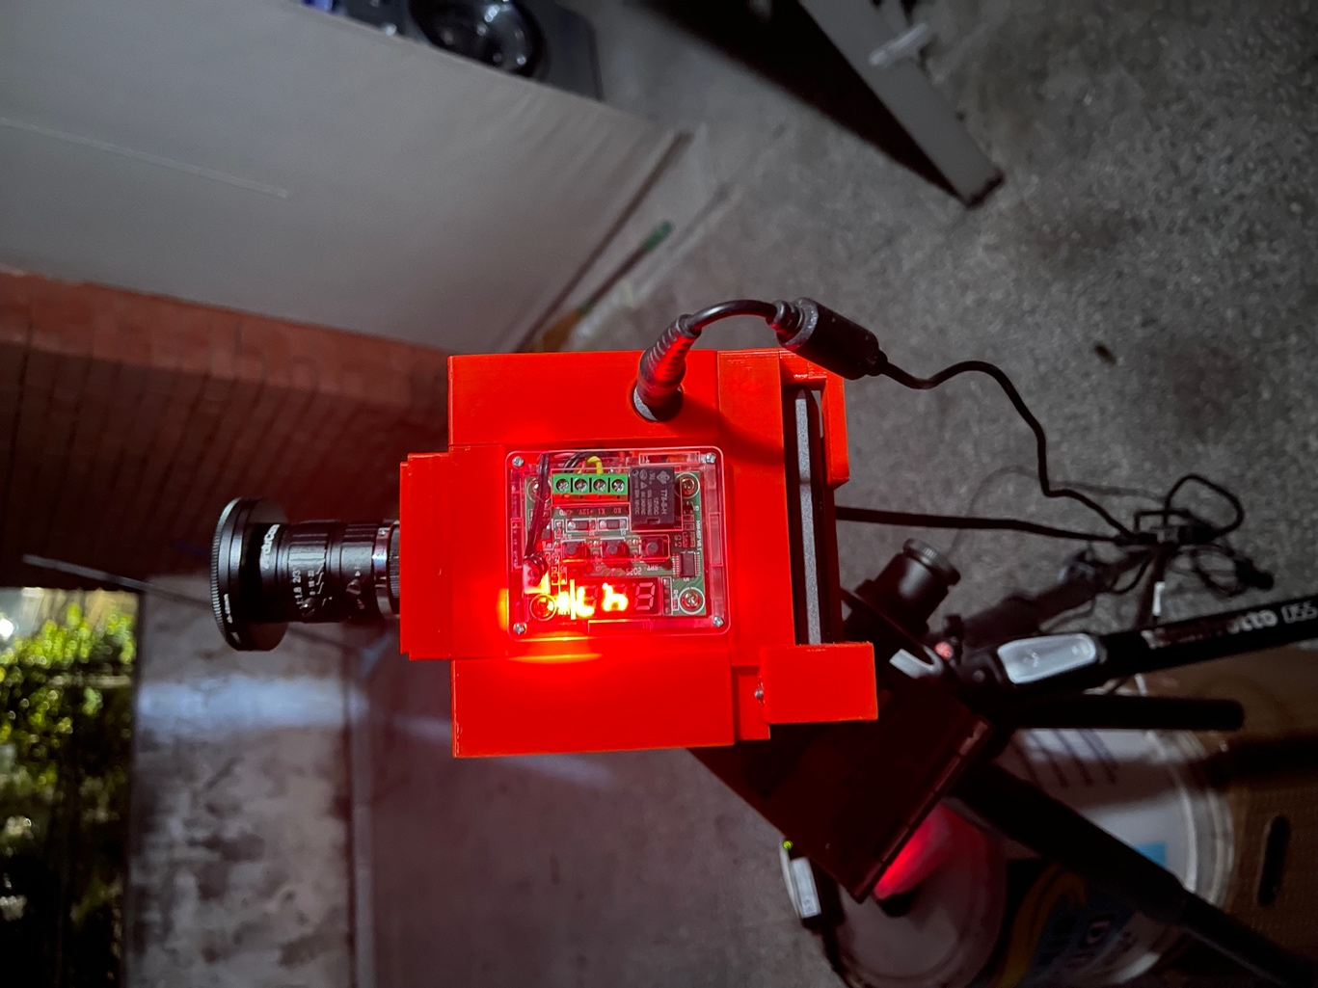

The camera on a barndoor tracker – managed a temperature of 4.7 degrees on a cool night

Other options –

The cooling parts can be all together removed from the design. Join the Parts 10 and 11 right below the Part-5 (part 4 is not required for this buid).

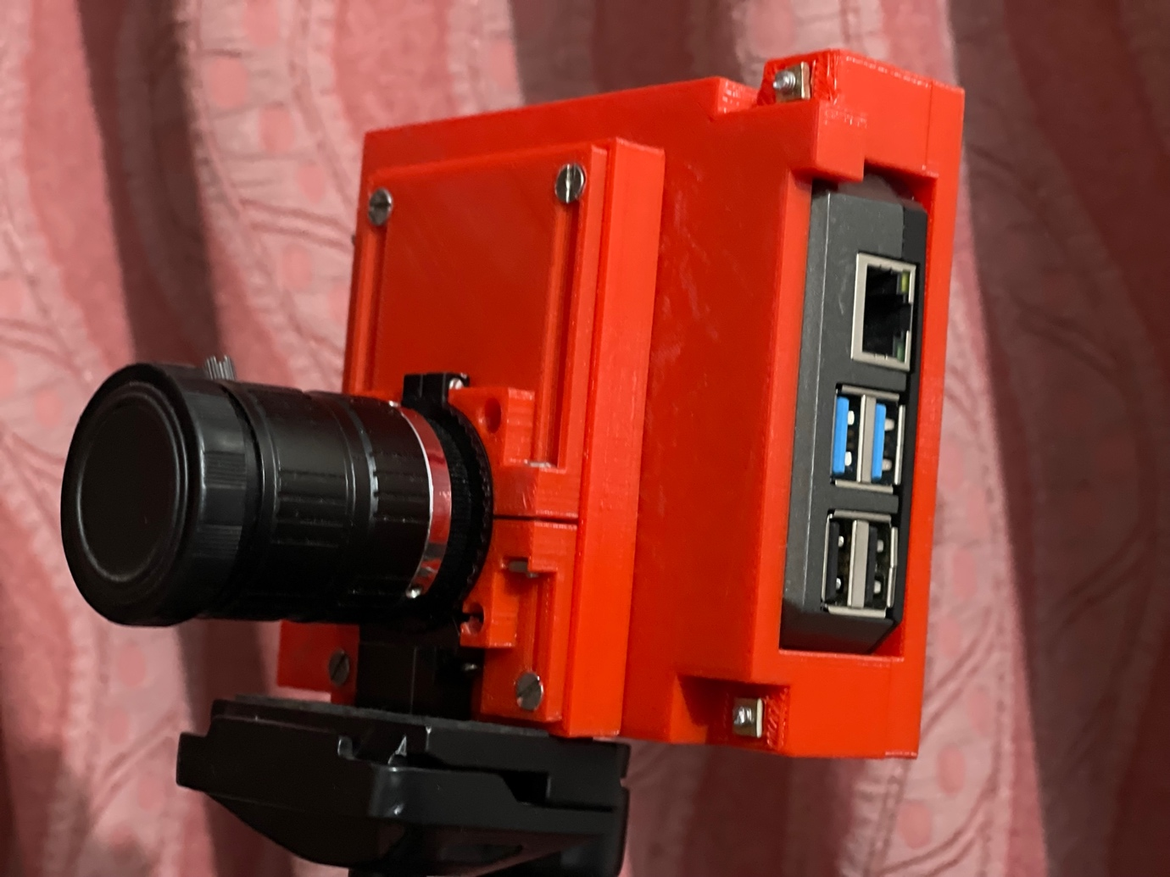

In this there are cut outs for the tripod mount of the RPi camera in the designed bracket and the camera is mounted using the built-in ball head mount.

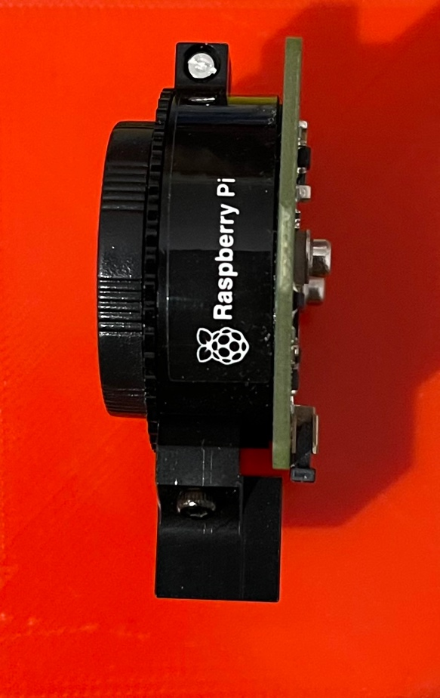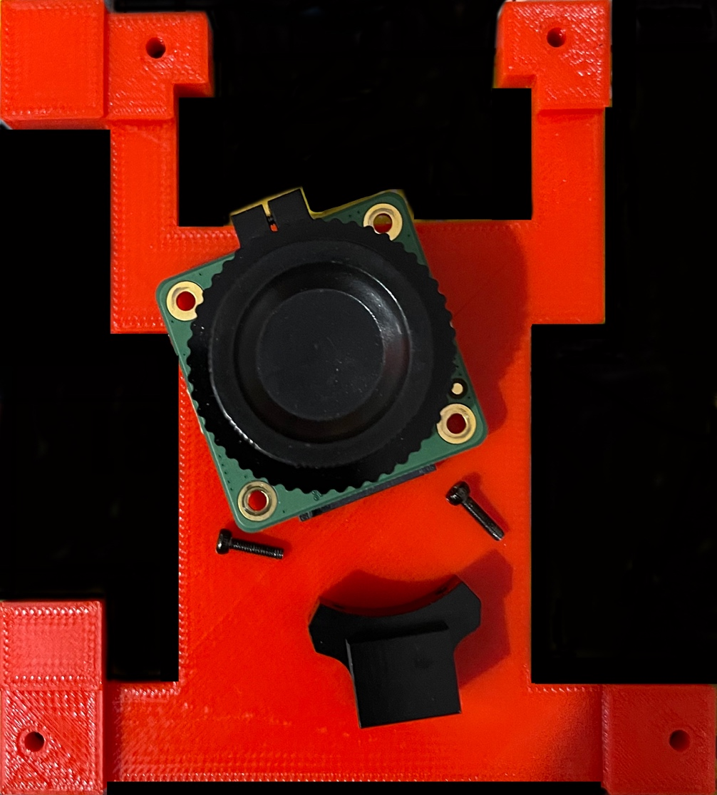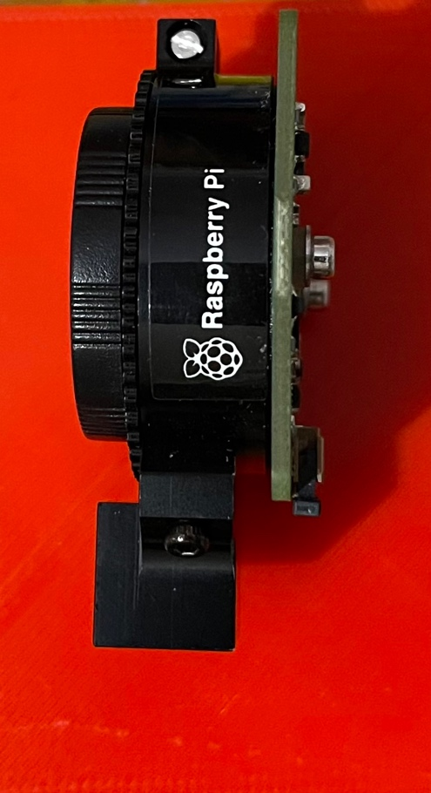

For this design to work, the tripod mount needs to be reversed as shown in above picture.

Support structures around tripod mount can also be used as it was observed that on certain ball heads, there was slight tilt when this was mounted.

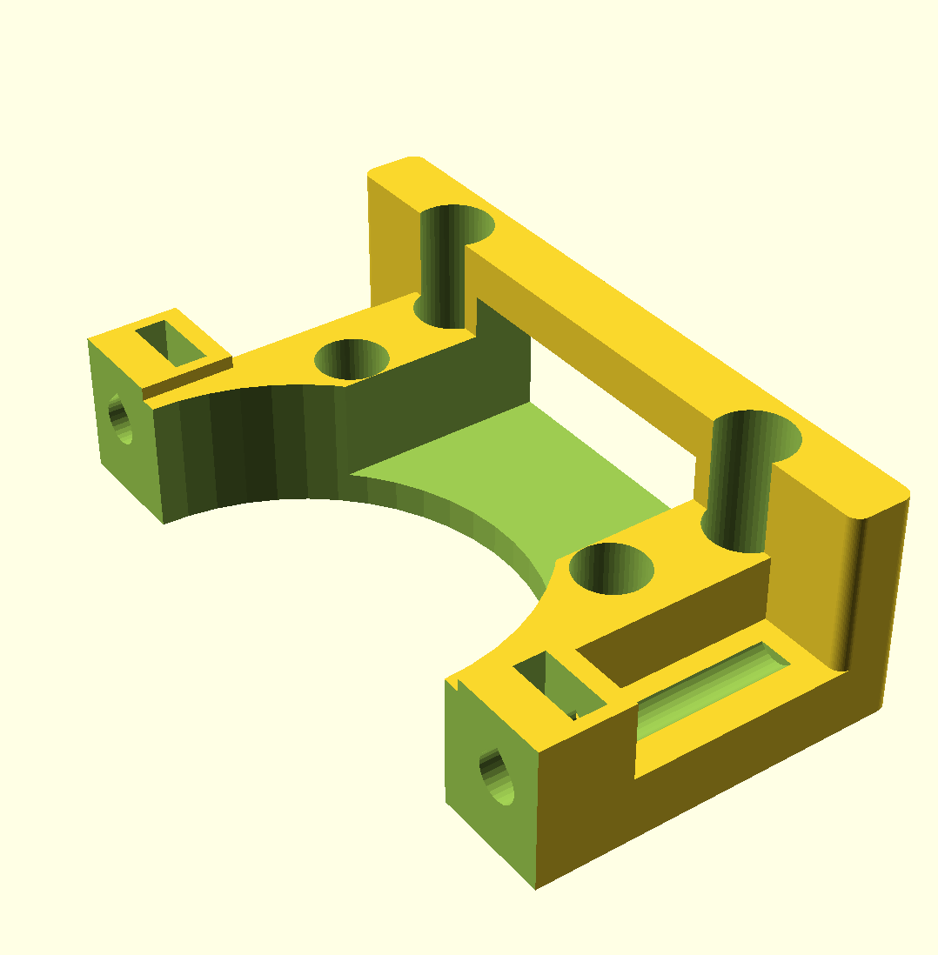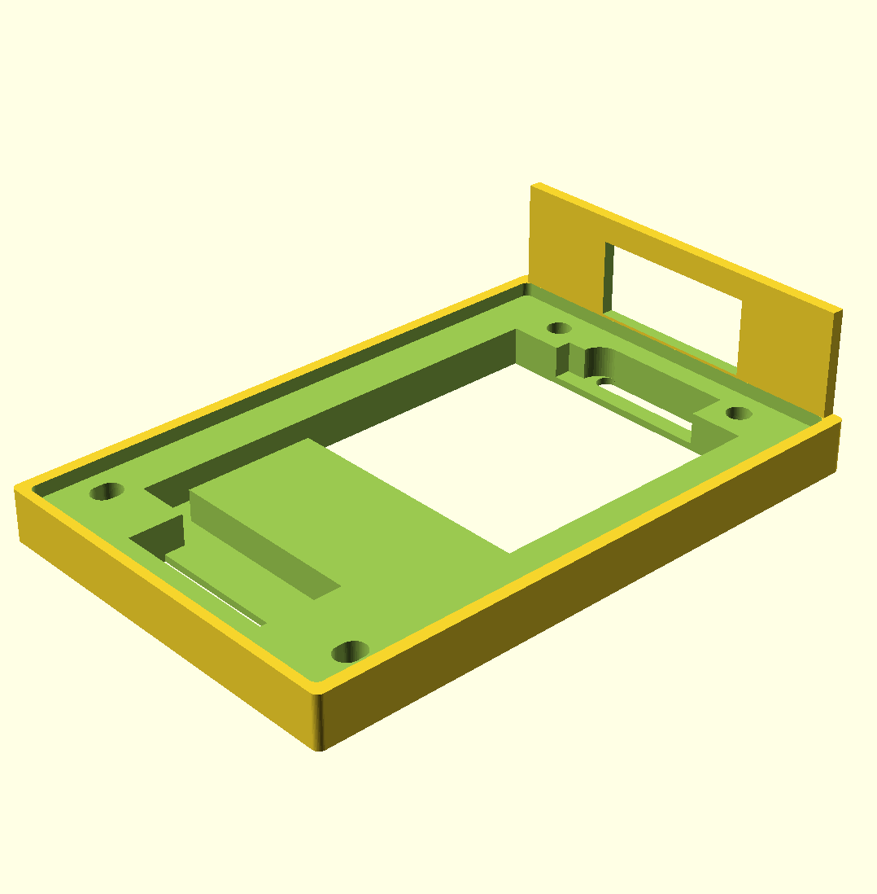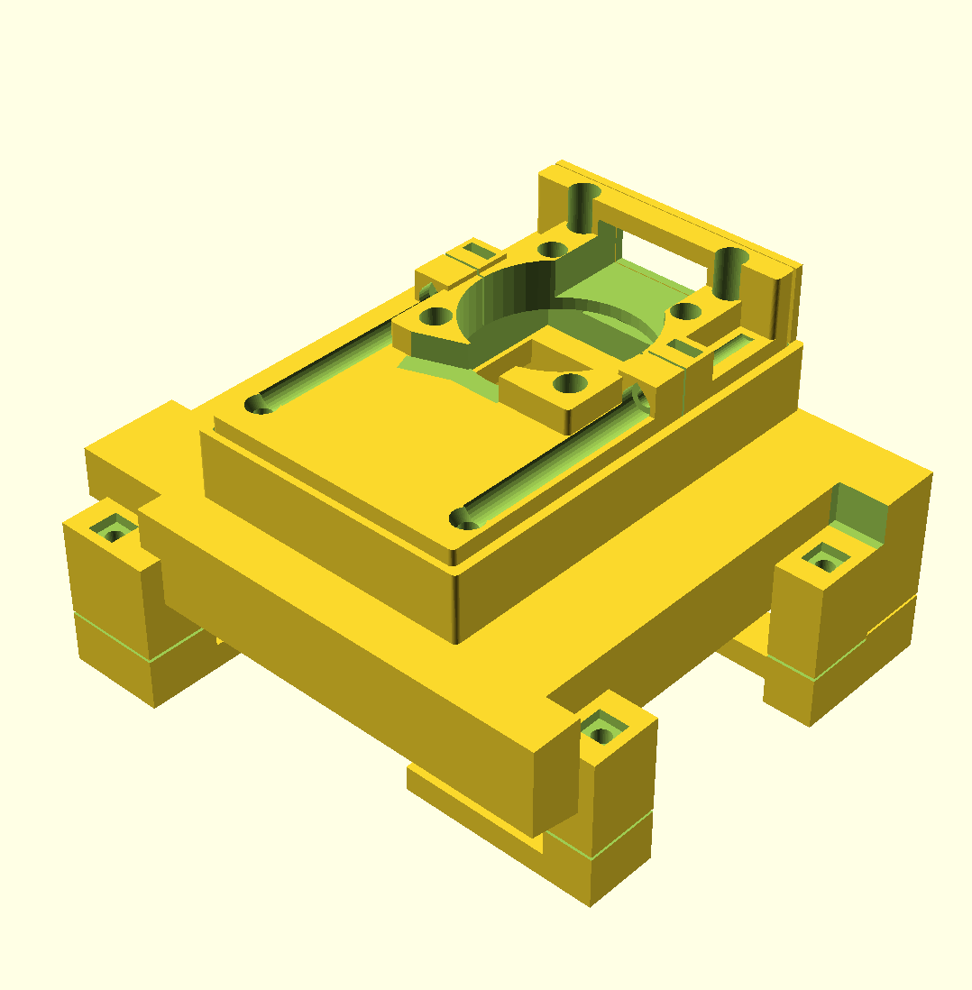

Haven’t tested this design though.